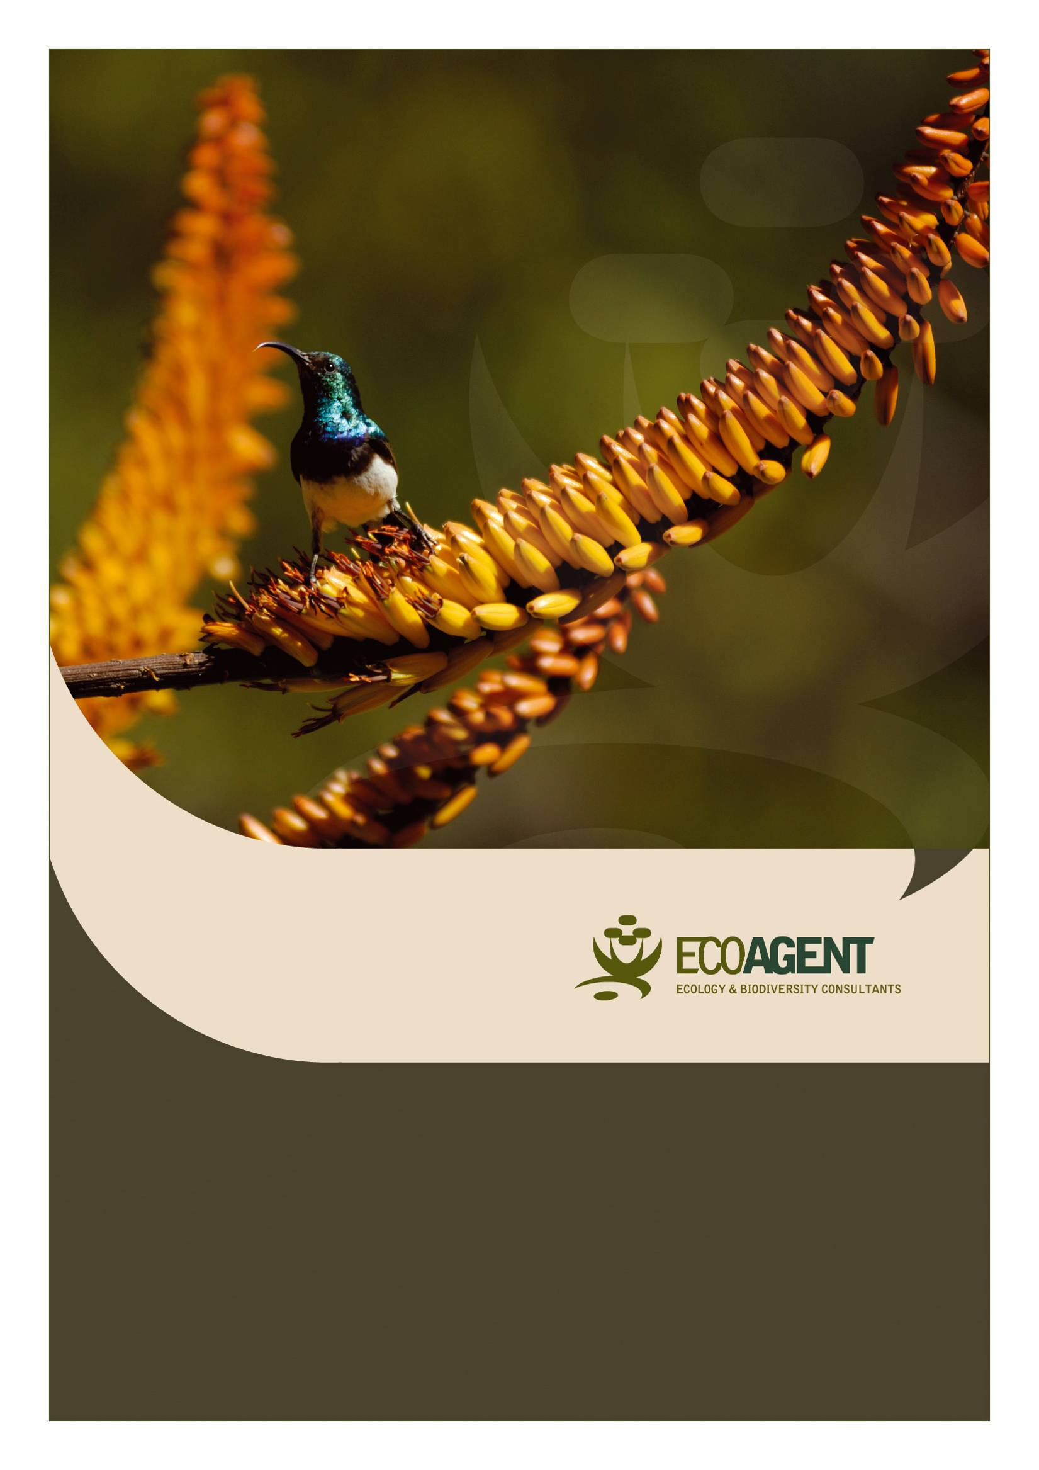
An evaluation of the plant and vertebrate diversity for the proposed route for the optic fibre cable between Johannesburg and Bloemfontein
February 2011
2010

An evaluation of the vegetation and plant diversity along the proposed route between the Eskom Merensky and Foskor substations

February 2012

An evaluation of the vegetation and plant diversity along the proposed route between the Eskom Merensky and Foskor substations

Prepared for:

Nsovo Environmental Consulting

by

G.J. Bredenkamp DSc., Pr.Sci.Nat.

EcoAgent CC
PO Box 23355
Monument Park
0181
Tel 012 4602525
Fax 012 460 2525
Cell 082 5767046

March 2012

Contents
DECLARATION OF INDEPENDENCE 5
EXECUTIVE SUMMARY 6
THE PROPOSED DEVELOPMENT 8
2. ASSIGNMENT 8
3. RATIONALE 10
4. STUDY AREA 11
4.1. General 11
6. METHODS 15
6.1 Vegetation and habitat survey 15
6.2 Conservation Priority / Sensitivity 16
7. RESULTS: 18
7.1 Vegetation Classification 18
7.2 Description of the vegetation types 21
Sekhukhune Plains Bushveld (Vulnerable) 21
Species of Conservation Concern 24
Conclusion 25
2. Sekhukhune Mountain Bushveld 26
Species of Conservation Concern 28
Conclusion 29
3. Ohrigstad Mountain Bushveld 29
a. Plains Bushveld 30
b. Mountain Slope Bushveld 32
Species of Conservation Concern 34
Conclusion 35
4. Lydenburg Thornveld 36
Species of Conservation Concern 38
Conclusion 39
5. Poung Dolomite Mountain Bushveld 40
Species of Conservation Concern 42
Conclusion 42
6. Northern Escarpment Quartzite Sourveld 43
7. Northern Mistbelt Forest 43
8. Tzaneen Sour Bushveld 44
Species of Conservation Concern 45
Conclusion 45
9. Granite Bushveld 47
Species of Conservation Concern 49
Conclusion 49
10. Lowveld Rugged Mopaneveld 51
Species of Conservation Concern 52
Conclusion 53
11. Phalaborwa-Timbavati Mopaneveld 53
Species of Conservation Concern 55
Conclusion 55
12 River and Spruit Systems 56
Conclusion 58
8 DISCUSSION 59
11. REFERENCES 61
ABRIDGED CURRICULUM VITAE: GEORGE JOHANNES BREDENKAMP 64

DECLARATION OF INDEPENDENCE
I, George Johannes Bredenkamp, Id 4602105019086, declare that I:
- Am the owner of Eco-Agent CC, CK 95/37116/23
- am committed to biodiversity conservation but concomitantly recognize the need for economic development. Whereas we appreciate the opportunity to also learn through the processes of constructive criticism and debate, we reserve the right to form and hold our own opinions and therefore will not willingly submit to the interests of other parties or change our statements to appease them;
- abide by the Code of Ethics of the S.A. Council for Natural Scientific Profession;
- Act as independent specialist consultants respectively in the fields of ecology, vegetation science and botany,
- am assigned as specialist consultant by Nsovo Environmental Consulting for the proposed project “An evaluation of the vegetation and plant diversity along the proposed route between the Eskom Merensky and Foskor substations” described in this report;
- do not have or will not have any financial interest in the undertaking of the activity other than remuneration for work performed;
- have or will not have any vested interest in the proposed activity proceeding;
- have no and will not engage in conflicting interests in the undertaking of the activity;
- undertake to disclose to the client and the competent authority any material information that have or may have the potential to influence the decision of the competent authority required in terms of the Environmental Impact Assessment Regulations 2006;
- will provide the client and competent authority with access to all information at our disposal, regarding this project, whether favourable or not.

JC

GJ Bredenkamp

EXECUTIVE SUMMARY
The vegetation of all four alternatives was investigated. From the desktop study, confirmed by the field survey, option 3, which runs from Burgersfort to Ohrigstad along the R555, was eliminated. This is because the route along the R555 runs for most of the way in a narrow valley, with the Mabitsana River and the tarred R555 in this valley. The line will have to run for most of the way on the sensitive mountain foot slopes and cross the river and road several times. Furthermore, many irrigated agricultural enterprises occur in the Ohrigstad area, stretching all the way to Marapeng. This mosaic of narrow river valley, river, mountain slopes and agriculture where-ever the valley is a bit broader, causes the route to be unsuitable. From an ecological perspective both the riverine vegetation and the vegetation of the mountain slopes have a high ecological sensitivity. Therefore this entire valley forms an ecologically sensitive ecosystem. This is also a much longer route.

Furthermore, from the desktop study, confirmed by the field survey, option 4, was eliminated. The line of this option runs through nine vegetation types, and over very high and steep mountains of Sekhukhune Mountain Bushveld and Ohrigstad Mountain Bushveld with two endangered ecosystems (Sekhukhune Mountainlands and Sekhukhune Norite Bushveld, SANBI & DEAT 2009), Poung Dolomite Mountain Bushveld with endangered Malmani Karstland (SANBI & DEAT 2009), the vulnerable Northern Escarpment Quartzite Sourveld (Mucina & Rutherford (2006), Northern Mistbelt Forest area and the vulnerable Tzaneen Sour Bushveld (SANBI & DEAT 2009). Especially the Great Escarpment area consists of very rugged and high mountains, resulting in a very difficult route with several threatened ecosystems.

Alternative Routes 1 and 2 were further investigated in more detail by field surveys. The vegetation along these routes is described in detail, including the protected and red data species. Medicinal plants and aliens and weeds are indicated.

The most difficult part of the route is from the Merensky substation through Orichstad Mountain Bushveld which is an extremely mountainous area with sensitive vegetation. This part of the line transects quite sensitive vegetation and it is suggested that a walkthrough in this area is essential.

The most serious limitation on the Lowveld plains where the line transects the Granite Lowveld vegetation type, is the abundance of the protected tree Sclerocarya birrea. It is certain that several of these trees will be in the way of the transect.
Locally are also the river and spruit crossings. No river or spruit is very wide, so the lines can easily cross these rivers or spruits systems. Care should be taken to place pylons adequately away from river or spruit banks, avoiding any damage to the banks or water courses. Erosion should be avoided at all times.

Another factor in this area is that large properties are game farms and lodges. These areas are effectively conserved by the owners, and it is realised that the public participation is an important issue. After finalisation of the exact transect, a walkthrough will have to confirm any issues regarding vegetation.

From an ecological perspective, Alternative 1 is the preferred route.

THE PROPOSED DEVELOPMENT
Eskom proposed the development of a new power line from the Merensky substation near Steelpoort to the Foskor substation near Phalaborwa. This power line is more than 120 km long. Alternative routes were proposed.

2. ASSIGNMENT
EcoAgent Ecological Consultants CC was appointed by Nsovo Environmental Consulting to assess the vegetation and flora for the entire route of proposed routes. This assignment is in accordance with the 2010 EIA Regulations (No. R. 543-546, Department of Environmental Affairs and Tourism, 18 June 2010) emanating from Chapter 5 of the National Environmental Management Act, 1998 (Act No. 107 of 1998).

The assignment is interpreted as follows: Compile a study of the vegetation and flora of the route, with emphasis on Red Data or Protected plant species that occur or may occur along the route. In order to compile this, the following had to be done:

2.1. Initial preparations:
- Obtain relevant maps and information on the natural environment of the concerned area.
- This includes information on Red Data plant species that may occur in the area.
- Obtain the Vegetation Types (Mucina & Rutherford, 2006) along the routes.

2.2. Vegetation and habitat survey:
- Use the Vegetation Types as basis for ecosystem delimitation.
- List the plant species (trees, shrubs, grasses and herbaceous species) present in the ecosystem recognised.
- Identify potential red data plant species, alien plant species, and medicinal plants.

2.3. Plant community delimitation and description
- Describe the habitat and vegetation.
- Determine the sensitivity of the site for biodiversity, veld condition and presence of rare or protected species.
2.4. General
- Identify and describe particular ecologically sensitive areas.
- Identify problem areas in need of special treatment or management, e.g. bush encroachment, erosion, water pollution, degraded areas, reclamation areas.
- This includes information on Red Data plant species that may occur in the area.

3. RATIONALE
It is widely recognised that it is of the utmost importance to conserve natural resources in order to maintain ecological processes and life support systems for plants, animals and humans. To ensure that sustainable development takes place, it is therefore important that the environment is considered before relevant authorities approve any development. This led to legislation protecting the natural environment. The Environmental Conservation Act (Act 73 of 1989), the National Environmental Management Act, 1998 (NEMA) (Act 107 of 1998) and the National Environmental Management Biodiversity Act, 2004. (Act 10 0f 2004) ensure the protection of ecological processes, natural systems and natural beauty as well as the preservation of biotic diversity in the natural environment. They also ensure the protection of the environment against disturbance, deterioration, defacement or destruction as a result of man-made structures, installations, processes or products or human activities. A draft list of Threatened Ecosystems was published (Government Gazette 2009) as part of the National Environmental Management Biodiversity Act, 2004 (Act 10 0f 2004). These Threatened Ecosystems are described by SANBI & DEAT (2009).

All components of the ecosystems (physical environment, vegetation, animals) of a site are interrelated and interdependent. A holistic approach is therefore imperative to include effectively the development, utilisation and where necessary conservation of the given natural resources in an integrated development plan, which will address all the needs of the modern human population (Bredenkamp & Brown 2001).

It is therefore necessary to make an inventory of the plant communities and biodiversity on the alternative routes, in order to evaluate the biodiversity and possible rare species. This inventory should then serve as a scientific and ecological basis for the planning exercises.

4. STUDY AREA

4.1. General
The different options suggested for the Merensky - Foskor Eskom power line are indicated in Figure 1. The northern parts of all options will traverse through conservation areas (Figure 2). All options start at the Merensky substation near Steelpoort. As the area is very large, many spruit systems are found along the routes (Figure 3). A few larger rivers or spruits are mentioned, but the numerous smaller spruit systems will have to be identified during a walk-down.

Option 1 (the preferred option) will run along the Steelpoort – Burgersfort road (R555) but before reaching Burgersfort it will turn north-eastwards and cross the rugged mountainous area towards the Strydom tunnel on the R36. It will then cross the mountains east of the Strydom tunnel and run towards Mica and from there towards the Foskor substation south of Phalaborwa.

Option 2 will follow the same route as option 1 up to the Mica area, but will then turn more east to run south and east of option 1, in the direction of Hoedspruit, and then turn northwards to the Foskor substation.

Option 3 will initially also follow the same route as option 1 for a short distance, but at Burgersfort it will turn eastwards and follow the R555 to Ohrigstad and further on to the Strydom tunnel. From here on the route is similar to that of option 1.

Option 4 will run northwards from the Merensky substation, over undulating and mountainous area towards Penge and then over the rugged mountains over the great escarpment to cross the R36 between Trichardsdal and Diputhi and then run through the Kapama / Madrid Nature Reserve area toward Phalaborwa.

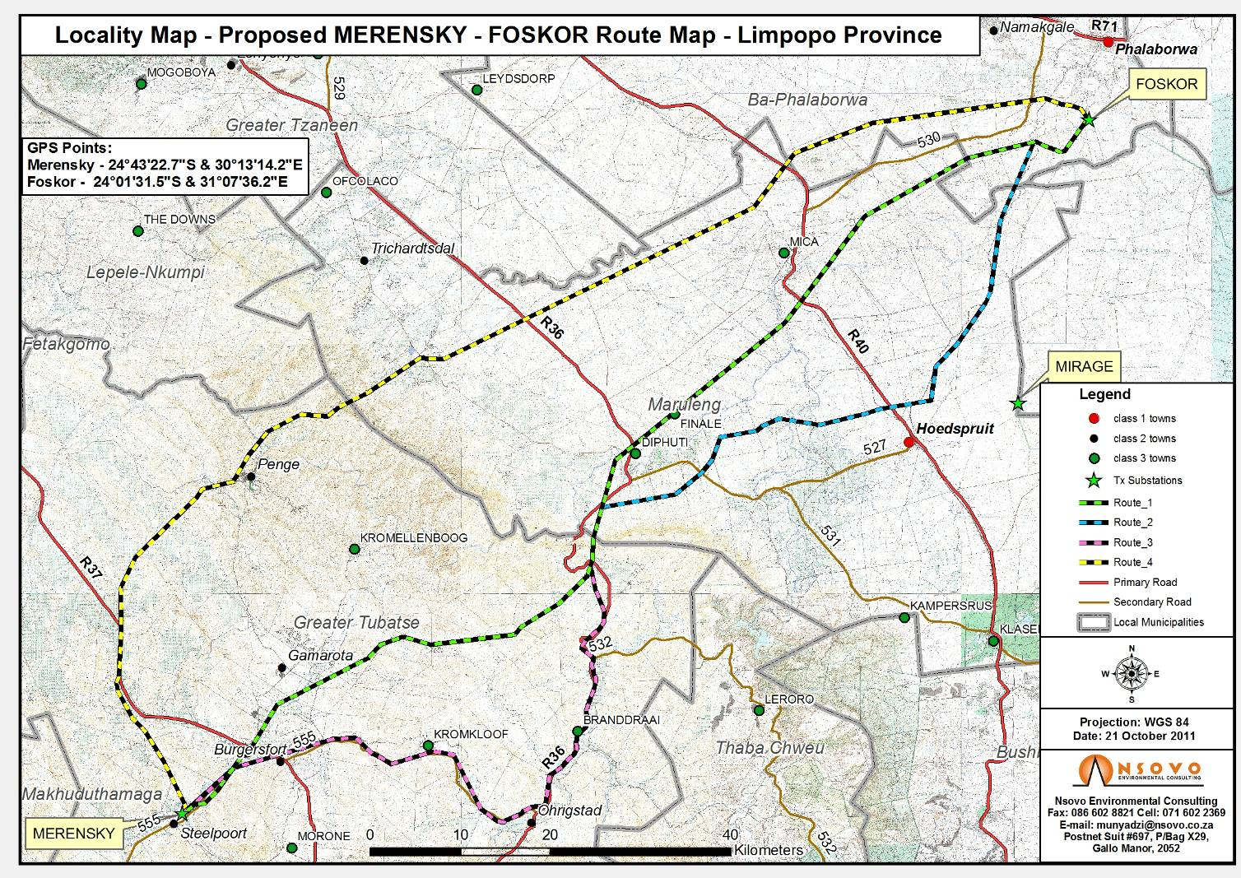
Figure 1: A locality map showing the different options for the Merensky Foskor Eskom power line
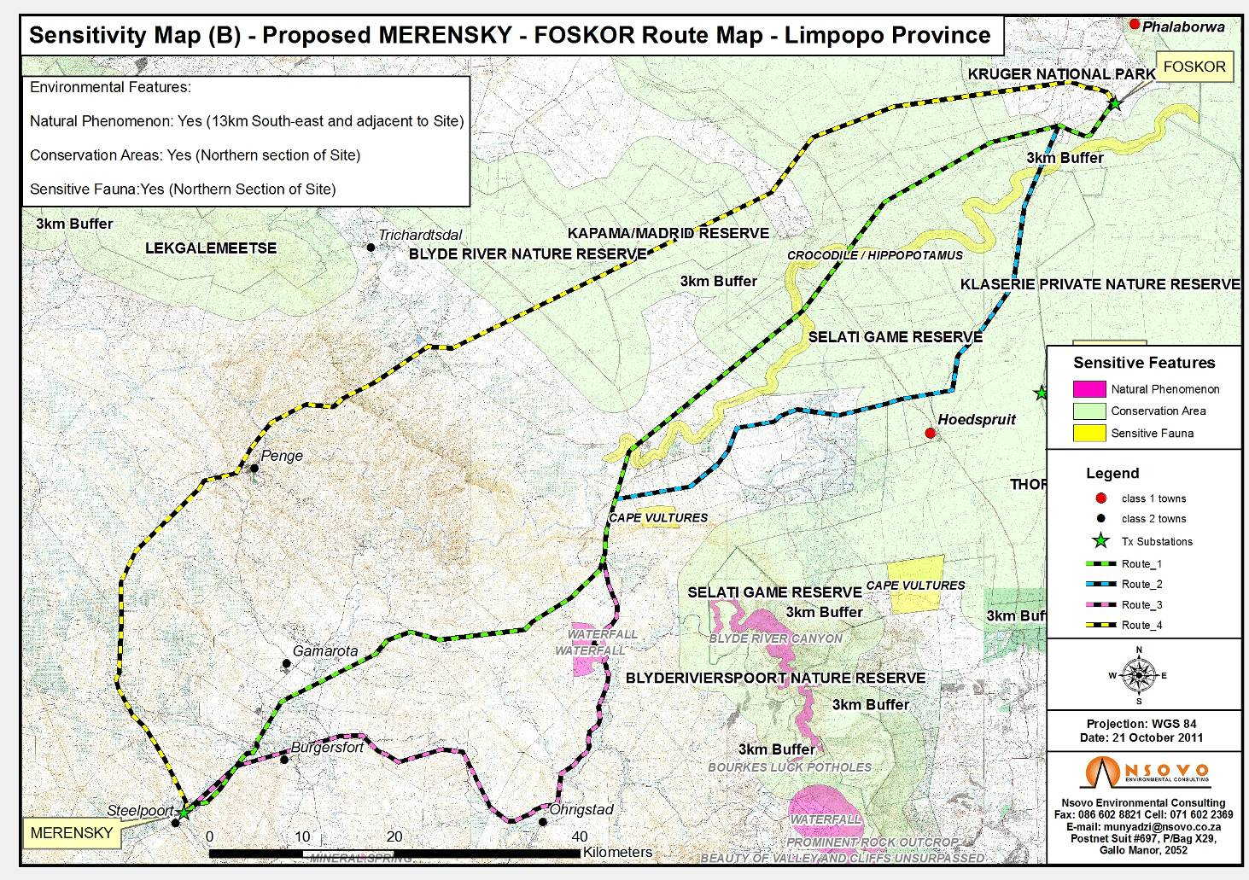
Figure 2: A locality map showing the different options for the Merensky Foskor Eskom power line with conservation and sensitive areas
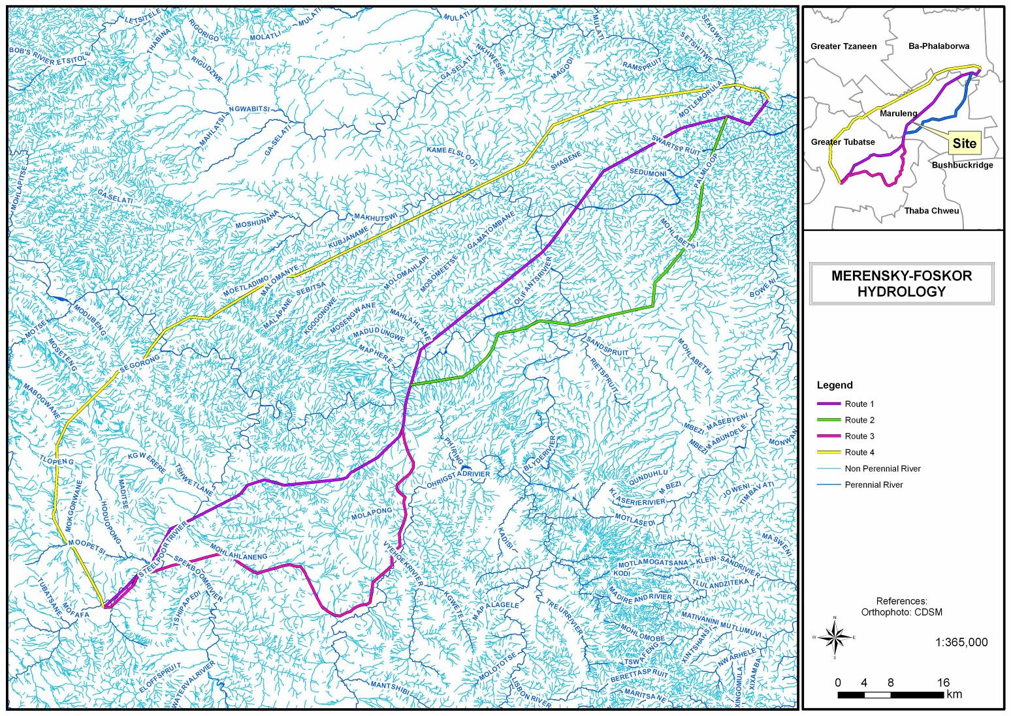
Figure 3: The hydrology of the area showing major river systems and numerous smaller spruits along all the route options

6. METHODS

6.1 Vegetation and habitat survey
A desktop study was made on the vegetation and flora fauna and general ecology and ecological sensitivity of the area along all options suggested for this power line. A site visit followed the desktop study.

The routes were driven on 24 and 25 October 2011 by Prof G.J. Bredenkamp, a delegation of Nsovo Environmental Consulting and also a delegation of Eskom. Staff members of Eskom gave guidance in the field on the location of the various options. Parts of the route, especially the south-western mountainous parts, were again visited during February 2012.

The vegetation of the route was stratified into relatively homogeneous units based on Vegetation Type Units (Mucina & Rutherford 2006). Regular stops were made in each vegetation unit identified, to record vegetation and plant species present and also on the conservation status, sensitivity and condition of the vegetation. Special features were identified as major river crossings, wetlands, rocky ridges or any other features considered to be of importance for the biodiversity assessment.

The general vegetation of the unit was described using both the desktop study and the field observations. For the particular vegetation type a description of the dominant and characteristic species was made at several sites within each Vegetation Type unit. These descriptions were based on total floristic composition, following established vegetation survey techniques (Mueller-Dombois & Ellenberg 1974; Westhoff & Van der Maarel 1978). Data recorded included a list of the plant species present, including trees, shrubs, grasses and forbs. Comprehensive species lists were therefore derived for each plant community / ecosystem present on the site. These vegetation survey methods have been used as the basis of a national vegetation survey of South Africa (Mucina et al. 2000) and are considered to be an efficient method of describing vegetation and capturing species information. Notes were additionally made of any other features that might have an ecological influence.

The identified systems are not only described in terms of their plant species composition, but also evaluated in terms of the potential habitat for red data plant species.

Red data plant species for the area were obtained from the SANBI data bases, with updated threatened status, (Raimondo et al 2009). These lists were then evaluated in terms of habitat available on the site, and also in terms of the present development and presence of man in the area.

Protected trees are according to the list provided by the National Forests Act 1998 (Act 84 of 1998). Other protected plants are according to the National Environmental
Management: Biodiversity Act, 2004 (Act No. 10 of 2004), or provincial regulations.

Alien invasive species, according to the Conservation of Agricultural Resources Act (Act No.43 of 1983) as listed in Henderson (2001), are indicated.

Medicinal plants are indicated according to Van Wyk, Van Oudthoorn & Gericke (1997), these are mentioned in the species lists.

6.2 Conservation Priority / Sensitivity
The following conservation priority / ecological sensitivity categories were used for each site:
High: Ecologically sensitive and valuable land with high species richness and/or sensitive ecosystems or red data species that should be conserved and no developed allowed.
Medium-high: Land where sections are disturbed but which is in general ecologically sensitive to development/disturbances.
Medium: Land on which low impact development with limited impact on the vegetation / ecosystem could be considered for development. It is recommended that certain portions of the natural vegetation be maintained as open space.
Medium-low: Land of which small sections could be considered to conserve but where the area in general has little conservation value.
Low: Land that has little conservation value and that could be considered for developed with little to no impact on the vegetation.

Species status
Plant species recorded in each plant community with an indication of the status of the species by using the following symbols:

A = Alien woody species
D = Dominant
d = subdominant
G = Garden or Garden Escape
M = Medicinal plant species
P = Protected trees species
p = provincially protected species
RD = Red data listed plant
W = weed

The field observations were supplemented by literature studies from the area (Bredenkamp 1982, Gertenbach 1983a, 1983b, Mathews 1991, Siebert 2001, Siebert et al. 2002a, 2002b, 2002c, 2002d 2002e and 2003).

7. RESULTS:

7.1 Vegetation Classification
According to the new vegetation map of South Africa (Mucina & Rutherford 2006) the routes transect the following vegetation types, Threatened Ecosystem Status is according to SANBI & DEAT (2009):

Vegetation Type | Route | Conservation status  (Mucina & Rutherford 2006) | Threatened Ecosystems  (SANBI & DEAT 2009) | Threatened Status
1. Sekhukhune Plains Bushveld | 1, 3, 4 | Vulnerable
2. Sekhukhune Mountain Bushveld | 4 | Least Threatened | Sekhukhune Mountainlands  Sekhukhune Norite Bushveld | Endangered  Endangered
3. Ohrigstad Mountain Bushveld | 1, 3, 4 | Least Threatened | Sekhukhune Mountainlands | Endangered
4. Lydenburg Thornveld | 1 | Vulnerable
5. Poung Dolomite Mountain Bushveld | 1, 3, 4 | Least Threatened | Malmani Karstlands | Endangered
6. Northern Escarpment Quartzite Sourveld | 4 | Vulnerable
7. Northern Mistbelt Forest | 4 | Least Threatened
8. Tzaneen Sour Bushveld | 4 (1, 2) | Least Threatened | Tzaneen Sour Bushveld | Vulnerable
9. Granite Bushveld | 1, 2, 4 | Least Threatened
10. Lowveld Rugged Mopaneveld | 1, 2 | Least Threatened
11. Phalaborwa-Timbavati Mopaneveld | 1, 4 | Least Threatened
12. River Crossings | all

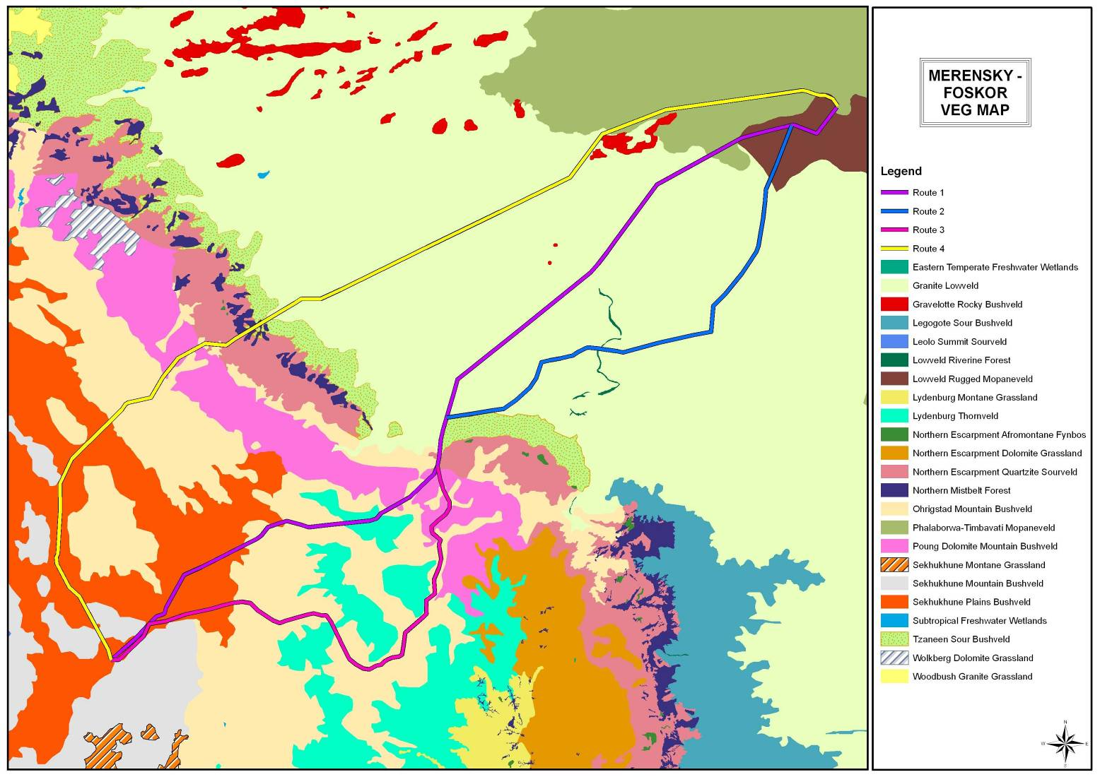
Figure 4: The vegetation types (Mucina & Rutherford 2006) along the optional routes

From the desktop study, confirmed by the field survey, option 3, which runs from Burgersfort to Ohrigstad along the R555, was eliminated. This is because the route along the R555 runs for most of the way in a narrow valley, with the Mabitsana River and the tarred R555 in this valley. The line will have to run for most of the way on the sensitive mountain foot slopes and cross the river and road several times. Furthermore, many irrigated agricultural enterprises occur in the Ohrigstad area, stretching all the way to Marapeng. This mosaic of narrow river valley, river, mountain slopes and agriculture where-ever the valley is a bit broader, causes the route to be unsuitable. From an ecological perspective both the riverine vegetation and the vegetation of the mountain slopes have a high ecological sensitivity. Therefore this entire valley forms an ecologically sensitive ecosystem. This is also a much longer route.

Furthermore, from the desktop study, confirmed by the field survey, option 4, was eliminated. The line of this option runs through nine vegetation types, and over very high and steep mountains of Sekhukhune Mountain Bushveld and Ohrigstad Mountain Bushveld with two endangered ecosystems (Sekhukhune Mountainlands and Sekhukhune Norite Bushveld, SANBI & DEAT 2009), Poung Dolomite Mountain Bushveld with endangered Malmani Karstland (SANBI & DEAT 2009), the vulnerable Northern Escarpment Quartzite Sourveld (Mucina & Rutherford (2006), Northern Mistbelt Forest area and the vulnerable Tzaneen Sour Bushveld (SANBI & DEAT 2009). Especially the Great Escarpment area consists of very rugged and high mountains, resulting in a very difficult route with several threatened ecosystems.

7.2 Description of the vegetation types

Sekhukhune Plains Bushveld (Vulnerable)
The Merensky substation is located in the Sekhukhune Plains Bushveld. Although the vegetation of these plains falls within the Sekhukhune Centre of plant endemism (Siebert 2001, Siebert et al. 2002a-e) this area is highly transformed by many villages and their agricultural fields. Within the study area this bushveld is restricted to the valley floors of the rivers that dissect the mountains. These areas are heavily grazed and often not in prime condition. This resulted in Mucina & Rutherford (2006) labelling the conservation status of this vegetation as Vulnerable.

Large parts of these plains are dominated by Dichrostachys cinerea, Acacia tortilis, Acacia mellifera and Acacia nilotica. Other plant species found here include the trees Boscia foetida, Euclea linearis, Searsia batophylla (along spruits and dongas) with the forbs Felicia clavipilosa, Hermannia odorata, Gisekia africana, Melhania rehmannii and the grasses Aristida congesta, Enneapogon cenchroides, Urochloa mosambicensis. Alien plant species are often found close to villages or along roads and tracks.

The following species were listed for this plant community:

TREES AND SHRUBS

Acacia gerrardii
Acacia mellifera d
Acacia nilotica d
Acacia tortilis D
Agave americana A
Aloe castanea p
Aloe cryptopoda p
Aloe globuligemma p
Balanites maughamii P
Boscia foetida
Dichrostachys cinerea D
Ehretia rigida
Euphorbia tirucalli
Grewia bicolor
Grewia flava
Lantana camara A
Melia azedarach A
Rhigozum obovatum
Sarcostemma viminale
Schotia latifolia RD
Sclerocarya birrea P
Searsia batophylla RD
Searsia engleri
Tinnea rhodesiana
Triaspis glaucophylla
Ziziphus mucronata M

GRASSES

Aristida adscensionis
Aristida congesta s. barbicollis
Cenchrus ciliaris
Chloris virgata
Dactyloctenium aegyptium
Enneapogon cenchroides
Enneapogon scoparius
Eragrostis heteromera
Eragrostis lehmanniana
Eragrostis superba
Fingerhuthia africana
Melinis repens s. repens
Panicum maximum
Sporobolus ioclados
Stipagrostis hirtigluma
Themeda triandra
Tragus berteronianus
Urochloa mosambicensis

FORBS

Abutilon angulatum
Acalypha indica
Achyranthes aspera v. sicula
Asparagus suaveolens
Bidens bipinnata W
Blepharis integrifolia
Clerodendrum ternatum
Corchorus asplenifolius
Datura stramonium WM
Felicia clavipilosa
Flaveria bidentis W
Galenia sarcophylla
Geigeria burkei
Gossypium herbaceum
Hermannia modesta
Hermbstaedtia odorata
Hibiscus caesius
Hibiscus micranthus
Jamesbrittenia atropurpurea
Jatropha latifolia
Justicia flava
Justicia protracta s. rhodesiana
Kohautia cynanchica
Lantana rugosa
Kleinia longiflora
Leonotis ocymifolia
Melhania acuminata
Melhania rehmannii
Monechma divaricatum
Ocimum americanum
Pavonia burchellii
Phyllanthus maderaspatensis
Pollichia campestris
Schkuhria pinnata W
Seddera fruticosa
Sesamum triphyllum W
Sesbania bispinosa
Sida alba
Solanum panduriforme W
Tephrosia purpurea
Tribulus terrestris W
Vernonia poskeana
Waltheria indica W
Zinnia peruviana W

Sekhukhune Plains Bushveld
Status | Dense to Disturbed plains bushveld
Soil | Clay-loam | Rockiness  % | 5-25
Conservation priority: | Medium | Sensitivity: | Medium
Agricultural potential: | Medium-Low | Need for rehabilitation | Medium
Dominant spp. | Acacia tortilis, Acacia mellifera, Dichrostachys cinerea, Euclea linearis

Species of Conservation Concern
A list of Species of Conservation Concern for the Grid 2627BB was obtained from the database on the SANBI website. Threatened species are those that are facing high risk of extinction, indicated by the categories Critically Endangered (CE), Endangered (EN) and Vulnerable (VU). Species of Conservation Concern include the Threatened Species, but additionally have the categories Near Threatened (NT), Data Deficient (DD), Critically Rare (CR), Rare (R) and Declining (D). This is in accordance with the new Red List for South African Plants (Raimondo et al. 2009).

The following species of conservation concern were previously recorded from the Grid 2430CA (SANBI, POSA website):

Species | Status
Dicliptera fruticosa K.Balkwill | NT
Elaeodendron transvaalense (Burtt Davy) R.H.Archer | NT
Lydenburgia cassinoides N.Robson | NT
Adenia fruticosa Burtt Davy subsp. fruticosa | NT
Searsia sekhukhuniensis (Moffett) Moffett | Rare
Combretum petrophilum Retief | Rare
Euphorbia sekukuniensis R.A.Dyer | Rare
Searsia batophylla (Codd) Moffett | VU
Zantedeschia jucunda Letty | VU
Gladiolus sekukuniensis P.J.D.Winter | VU
Acacia sekhukhuniensis P.J.H.Hurter | CR
Delosperma rileyi L.Bolus | DDD
Asparagus intricatus (Oberm.) Fellingham & N.L.Mey. | DDT
Acalypha caperonioides Baill. var. caperonioides | DDT
Myrothamnus flabellifolius Welw. | DDT
Ilex mitis (L.) Radlk. var. mitis | Declining
Drimia altissima (L.f.) Ker Gawl. | Declining
Hypoxis hemerocallidea Fisch., C.A.Mey. & Avé-Lall. | Declining
Eulophia speciosa (R.Br. ex Lindl.) Bolus | Declining

Searsia batophylla, Hypoxis hemerocallidea and Eulophia speciosa were observed within the transect area. For most of the other species the plains habitat is not suitable, they are present on the mountain areas of Sekhukhuneland.

Balanites maughamii and Sclerocarya birrea are nationally protected trees observed along the route while the Aloe species are all provincially protected.

Conclusion
The vegetation within on the plains are quite disturbed, there are often villages, roads, tracks and current or old agricultural fields present. As the pylons of the power line will have a relatively small footprint, the impact on the vegetation will be small. However, due to the presence of red data and possibly protected plant species, a walkthrough is recommended for this area, to ensure that sensitive areas are excluded for construction of pylons.
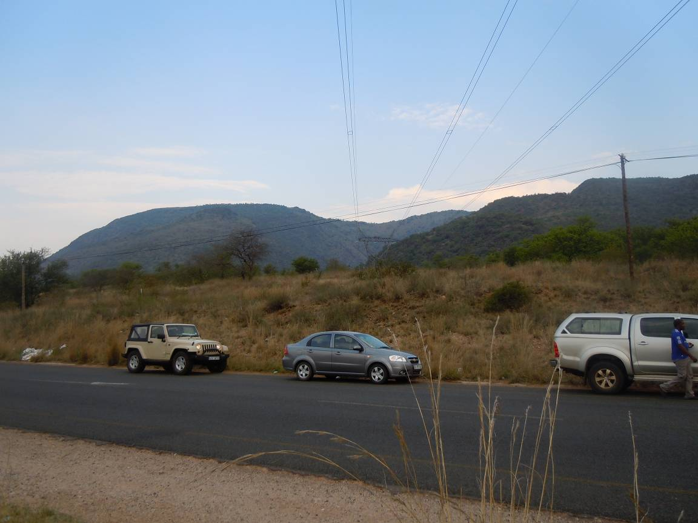
Figure 5: Sekhukhune Plains Bushveld in the foreground and Sekhukhune Mountain Bushveld in the Background

2. Sekhukhune Mountain Bushveld
This Open Mountain Bushveld occurs patchy throughout the area, the soils contain high concentrations of heavy metals and the area is often prone to mining operations. In this study very small part of this Bushveld is affected, the largest piece is just north of Steelpoort along route option 4, which was already eliminated. However, being a very sensitive ecosystem, due to several endemic and threatened species, the description is included.

Trees and Shrubs

Acacia ataxacantha,
Acacia gerrardii
Acacia mellifera s. detinens
Acacia nigrescens,
Acacia nilotica
Acacia senegal v. leiorhachis
Acacia senegal v. rostrata
Acacia tortilis s. heteracantha
Aloe arborescens p
Aloe castanea p
Aloe cryptopoda p
Boscia foetida
Brachylaena ilicifolia
Carissa bispinosa
Celtis africana
Combretum apiculatum
Combretum hereroense
Combretum molle
Combretum petrophilum RD
Commiphora mollis
Croton gratissimus
Cussonia transvaalensis
Dichrostachys cinerea
Elephantorrhiza praetermissa
Elaeodendron transvaalense RD
Euclea linearis
Euclea undulata M
Grewia flava
Grewia vernicosa
Hippobromus pauciflorus
Kirkia wilmsii
Maerua cafra
Maytenus undata
Lydenburgia cassinoides RDP
Ormocarpum trichocarpum
Ozoroa sphaerocarpa
Rhoicissus sekhukhuniensis
Sclerocarya birrea P
Searsia keetii
Searsia sekhukhuniensis RD
Searsia wilmsii
Terminalia prunioides
Tinnea rhodesiana
Vitex obovata subsp wilmsii

Grasses

Aristida canescens
Aristida canescens,
Aristida transvaalensis
Bothriochloa insculpta
Brachiaria eruciformis
Digitaria eriantha
Diheteropogon amplectens
Elionurus muticus
Enneapogon scoparius
Eragrostis lehmanniana
Eragrostis superba
Fingerhuthia africana
Heteropogon contortus
Loudetia simplex
Melinis repens
Panicum deustum
Sporobolus ioclados
Themeda triandra

Forbs

Abutilon angulatum
Adenia fruticosa RD
Asparagus cooperi
Asparagus suaveolens
Barleria kaloxytona
Barleria saxatilis
Berkheya insignis
Blepharis aspera
Blepharis integrifolia
Clerodendrum ternatum
Commelina africana
Corchorus asplenifolius
Crabbea angustifolia
Cyphostemma coddii
Ectadiopsis oblongifolia
Euphorbia enormis
Euphorbia schinzii
Evolvulus alsinoides
Geigeria burkei
Gerbera jamesonii
Hibiscus aethiopicus
Hypoestes forskaolii
Kohautia cynanchica
Kyphocarpa angustifolia
Melhania rehmannii
Merwilla plumbea RD
Monechma divaricatum
Myrothamnus flabellifolius RD
Ocimum americanum
Phyllanthus glaucophyllus
Polygala hottentotta
Ptycholobium plicatum
Rhynchosia minima
Sansevieria hyacinthoides
Seddera capensis
Senna italica
Stylochiton natalensis
Stylochiton sp
Syncolostemon concinnus
Tephrosia purpurea
Tetradenia brevispicata,
Tragia dioica
Waltheria indica W
Xerophyta retinervis

Sekhukhune Mountain Bushveld
Status | Dense to Disturbed mountain bushveld
Soil | Clay-loam | Rockiness  % | 5-25
Conservation priority: | High | Sensitivity: | High
Agricultural potential: | Low | Need for rehabilitation | Low
Dominant spp. | Combretum apiculatum, Grewia vernicosa, Dichrostachys cinerea, Euclea linearis and Euclea undulata

Species of Conservation Concern
A Threatened species and Species of Conservation Concern list for the Grid 2627BB was obtained from the POSA database on the SANBI website. Threatened species are those that are facing high risk of extinction, indicated by the categories Critically Endangered (CE), Endangered (EN) and Vulnerable (VU). Species of Conservation Concern include the Threatened Species, but additionally have the categories Near Threatened (NT), Data Deficient (DD), Critically Rare (CR), Rare (R) and Declining (D). This is in accordance with the new Red List for South African Plants (Raimondo et al. 2009).

The following species of conservation concern were previously recorded from the Grid 2430CA (SANBI, POSA website):

Species | Status
Dicliptera fruticosa K.Balkwill | NT
Elaeodendron transvaalense (Burtt Davy) R.H.Archer | NT
Lydenburgia cassinoides N.Robson | NT
Adenia fruticosa Burtt Davy subsp. fruticosa | NT
Searsia sekhukhuniensis (Moffett) Moffett | Rare
Combretum petrophilum Retief | Rare
Euphorbia sekukuniensis R.A.Dyer | Rare
Searsia batophylla (Codd) Moffett | VU
Zantedeschia jucunda Letty | VU
Gladiolus sekukuniensis P.J.D.Winter | VU
Acacia sekhukhuniensis P.J.H.Hurter | CR
Delosperma rileyi L.Bolus | DDD
Asparagus intricatus (Oberm.) Fellingham & N.L.Mey. | DDT
Acalypha caperonioides Baill. var. caperonioides | DDT
Myrothamnus flabellifolius Welw. | DDT
Ilex mitis (L.) Radlk. var. mitis | Declining
Drimia altissima (L.f.) Ker Gawl. | Declining
Hypoxis hemerocallidea Fisch., C.A.Mey. & Avé-Lall. | Declining
Eulophia speciosa (R.Br. ex Lindl.) Bolus | Declining

Elaeodendron transvaalense, Combretum petrophilum, Lydenburgia cassinoides, Adenia fruticosa, Myrothamnus flabellifolius and Searsia sekhukhuniensis were observed close to the transect area. Merwilla plumbea, not listed above, was also seen. The habitat is also suitable for most of the other threatened species listed.

The protected trees Lydenburgia cassinoides and Sclerocarya birrea are present.

Conclusion
The vegetation on the mountains contains several red data and protected plant species, where-ever possible the mountain areas of Sekhukhuneland should be avoided. It seems that although this type of Bushveld is prominent between Steelpoort and Burgersfort, the proposed line will seldom transect these mountains, except for Route 4, which is already eliminated. However, should any line cross this vegetation type, a walkthrough is recommended for this area, to ensure that sensitive areas are excluded for construction of pylons.

3. Ohrigstad Mountain Bushveld
Ohrigstad Mountain Bushveld is present in the Burgersfort – Ohrigstad and Penge areas. (present for options 1, 3 and 4, not for option 2). This Mountain Bushveld also has, as the Sekhukhune Mountain Bushveld, high species diversity and several plant species of conservation concern. However, this area consists of mountains and valleys, both being important for this survey. Option 3 runs for most of the way in a prominent valley, containing plains bushveld, but often has to run over the footslopes of the mountains.

Option 3, which runs from Burgersfort to Ohrigstad along the R555, was eliminated. This is because the route along the R555 runs for most of the way in a narrow valley, with the Mabitsana River and the tarred R555 in this valley. The line will have to run for most of the way on the sensitive mountain foot slopes and cross the river and road several times. Furthermore, many irrigated agricultural enterprises occur in the Ohrigstad area, stretching all the way to Marapeng. This mosaic of narrow river valley, river, mountain slopes and agriculture where-ever the valley is a bit broader, causes the route to be unsuitable. From an ecological perspective both the riverine vegetation and the vegetation of the mountain slopes have a high ecological sensitivity. Therefore this entire valley forms an ecologically sensitive ecosystem. This is also a much longer route.

The two main plant communities found in this area are: a) The Plains Bushveld in the Valleys and b) the Mountain slope Bushveld. These are described separately.

a. Plains Bushveld
The Dense Plains Bushveld is restricted to the Ohrigstad valley, the route of Option 3. This is degraded to pristine bushveld with a dense woody cover. The vegetation is dominated by Acacia tortilis, Dichrostachys cinerea, Combretum apiculatum, Euclea linearis and Euclea undulata, while Eragrostis rigidior, Enneapogon scoparius and Themeda triandra are prominent in the grass layer.

The following plant species were recorded from this plant community:

Trees and Shrubs

Acacia tortilis d
Aloe castanea p
Aloe marlothii p
Berchemia zeyheri M
Combretum apiculatum M
Dichrostachys cinerea d
Ehretia rigida M
Euclea linearis d
Euclea undulata dM
Euphorbia cooperi
Euphorbia tirucalli M
Grewia monticola
Gymnosporia senegalensis M
Hexalobus monopetalus
Karomia speciosa
Mundulea sericea M
Ormocarpum trichocarpum
Peltophorum africanum M
Ptaeroxylon obliquum M
Rhoicissus tridentata M
Sclerocarya birrea PM
Searsia leptodictya
Tarchonanthus camphoratus M
Ximenia americana M
Ziziphus mucronata M

Grasses

Aristida congesta
Aristida congesta subsp barbicollis
Bothriochloa insculpta
Brachiaria nigropedata
Cymbopogon excavatus
Digitaria eriantha
Enneapogon scoparius d
Eragrostis rigidior d
Eragrostis superba
Heteropogon contortus d
Melinis repens
Panicum maximum
Pogonarthria squarrosa
Setaria sphacelata
Themeda triandra d
Urochloa mosambicensis

Forbs

Abutilon austroafricanum
Aloe cryptopoda p
Aloe fosteri p
Barleria cf guenzii
Chascanum hederaceum
Commelina africana M
Cucumis zeyheri M
Datura stramonium WM
Evolvulus alsinoides M
Hibiscus micrantha
Hibiscus trionum
Hypoestes aristata M
Ipomoea magnusiana
Kyphocarpa angustifolia
Pentarrhinum insipidum M
Senecio tamoides M
Solanum incanum M
Solanum nigrum WM
Solanum panduriforme M
Tephrosia sp

Ohrigstad Mountain Bushveld: Plains Bushveld
Status | Dense to Disturbed plains bushveld
Soil | sandy-loam | Rockiness  % | 1
Conservation priority: | Medium-High | Sensitivity: | Medium-High
Agricultural potential: | Medium to High (irrigation) | Need for rehabilitation | Low
Dominant spp. | Acacia tortilis, Combretum apiculatum, Dichrostachys cinerea, Euclea linearis and Euclea undulata

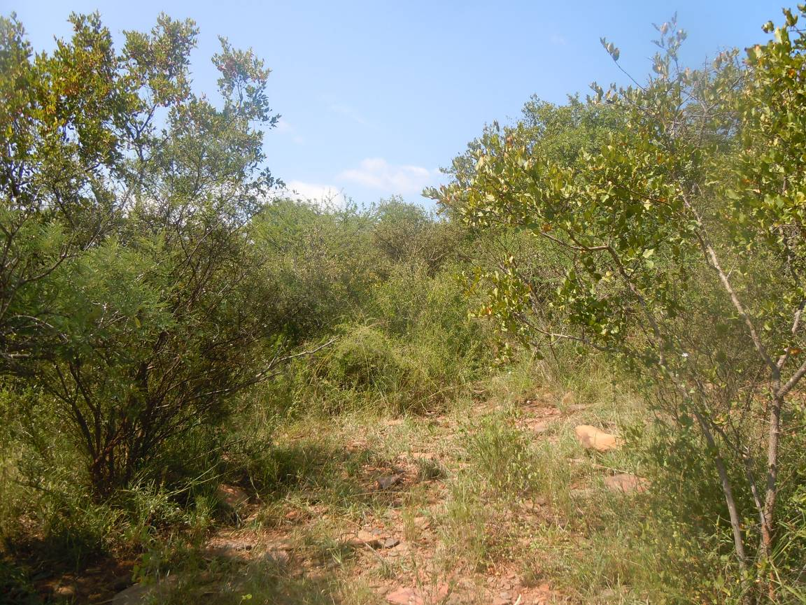
Figure 6: The Dense Plains Bushveld of the area

b. Mountain Slope Bushveld
The mountain slopes, facing in all directions, as the valley curves through the mountains are covered with dense Mountain Slope Bushveld. This is often pristine mountain bushveld with a dense woody cover, though the herbaceous layer is poorly developed due to the dense woody layer. Many woody species occur in this plant community, with Combretum apiculatum and Tarchonanthus camphoratus prominent. Aristida congesta subsp barbicollis, Eragrostis rigidior, Eragrostis lehmanniana and Enneapogon scoparius are the most conspicuous grass species in the scanty herbaceous layer.

The following plant species were recorded from this plant community:

Trees and Shrubs

Acacia exuvialis
Acacia tortilis d
Berchemia zeyheri M
Combretum apiculatum DM
Crotalaria monteiroi
Dichrostachys cinerea
Ehretia rigida M
Elaeodendron transvaalense PM
Euclea linearis d
Euclea natalensis M
Euclea undulata dM
Euphorbia ingens
Euphorbia tirucalli M
Flueggea virosa M
Grewia bicolor
Grewia monticola
Gymnosporia senegalensis M
Hexalobus monopetalus
Karomia speciosa
Mundulea sericea M
Opuntia ficus-indica A
Ormocarpum trichocarpum
Pappea capensis
Peltophorum africanum M
Phyllanthus reticulatus
Ptaeroxylon obliquum M
Rhoicissus tridentata M
Sclerocarya birrea P
Searsia leptodictya
Tarchonanthus camphoratus dM
Ximenia americana M
Ziziphus mucronata M

Grasses

Aristida congesta subsp barbicollis d
Digitaria eriantha
Enneapogon scoparius d
Eragrostis lehmanniana d
Eragrostis rigidior d
Heteropogon contortus
Panicum maximum
Sporobolus fimbriatus

Forbs

Abutilon austroafricanum
Aloe cryptopoda p
Aloe fosteri p
Asparagus sp
Barleria cf guenzii
Commelina africana M
Evolvulus alsinoides M
Hibiscus micrantha
Kalanchoe paniculata M
Kyphocarpa angustifolia
Melhania prostrata
Pentarrhinum insipidum M
Solanum incanum M
Stylosanthes fruticosa
Waltheria indica W

Ohrigstad Mountain Bushveld: Mountain Slope Bushveld
Status | Pristine mountain bushveld
Soil | Rocky shallow sandy | Rockiness  % | 5-20
Conservation priority: | High | Sensitivity: | High
Agricultural potential: | Low | Need for rehabilitation | Low
Dominant spp. | Combretum apiculatum, Euclea linearis, Euclea undulata, Tarchonanthus camphoratus

Species of Conservation Concern
A Threatened species and Species of Conservation Concern list for the Grid 3325DB was obtained from the POSA database on the SANBI website. Threatened species are those that are facing high risk of extinction, indicated by the categories Critically Endangered, Endangered and Vulnerable. Species of Conservation Concern include the Threatened Species, but additionally have the categories Near Threatened, Data Deficient, Critically Rare, Rare and Declining. This is in accordance with the new Red List for South African Plants (Raimondo et al. 2009).

The following species of conservation concern were previously recorded from the Grid 2430DA (SANBI, POSA website April 2011):

Species | Status
Adenia fruticosa Burtt Davy subsp. fruticosa | NT
Aloe fouriei D.S.Hardy & Glen | DDT
Ansellia africana Lindl. | Declining
Ceropegia distincta N.E.Br. subsp. verruculosa R.A.Dyer | DDD
Combretum petrophilum Retief | Rare
Dicliptera fruticosa K.Balkwill | NT
Dracaena transvaalensis Baker | Rare
Eulophia speciosa (R.Br. ex Lindl.) Bolus | Declining
Euphorbia sekukuniensis R.A.Dyer | Rare
Gladiolus macneilii Oberm. | CR
Gladiolus pavonia Goldblatt & J.C.Manning | CR
Indigofera leendertziae N.E.Br. | DDT
Jamesbrittenia macrantha (Codd) Hilliard | NT
Khadia alticola Chess. & H.E.K.Hartmann | Rare
Lydenburgia cassinoides N.Robson | NT
Ocimum tubiforme (R.D.Good) A.J.Paton | CR
Orbea gerstneri (Letty) Bruyns subsp. gerstneri | Rare
Pentatrichia alata S.Moore | DDD
Rhoicissus laetans Retief | Rare
Searsia batophylla (Codd) Moffett | VU
Thesium davidsonae Brenan | VU

Lydenburgia cassinoides was found during the field visit in this area. There is suitable habitat for several of the threatened plant species along the transect of this Option of the power line, especially for Adenia fruticosa subsp. fruticosa, Ocimum tubiforme, Orbea gerstneri subsp. gerstneri and Combretum petrophilum, but none of these species were found on the site during the field visit.

Conclusion
This plant community is high in species richness with several red data species. A few individuals of the protected Elaeodendron transvaalensis, Sclerocarya birrea, Aloe fosteri and Aloe cryptopoda are found in this vegetation. The conservation value and sensitivity are regarded as being high, due to biodiversity and also due to the ecological function of the mountains and the valley as a dispersal corridor for plants and animals. There is also abundant farming activities in the valley, including irrigated crops. There will be several turning points for the line, as the road winds through the valley. It is suggested that this option not be used due to the several constraints.

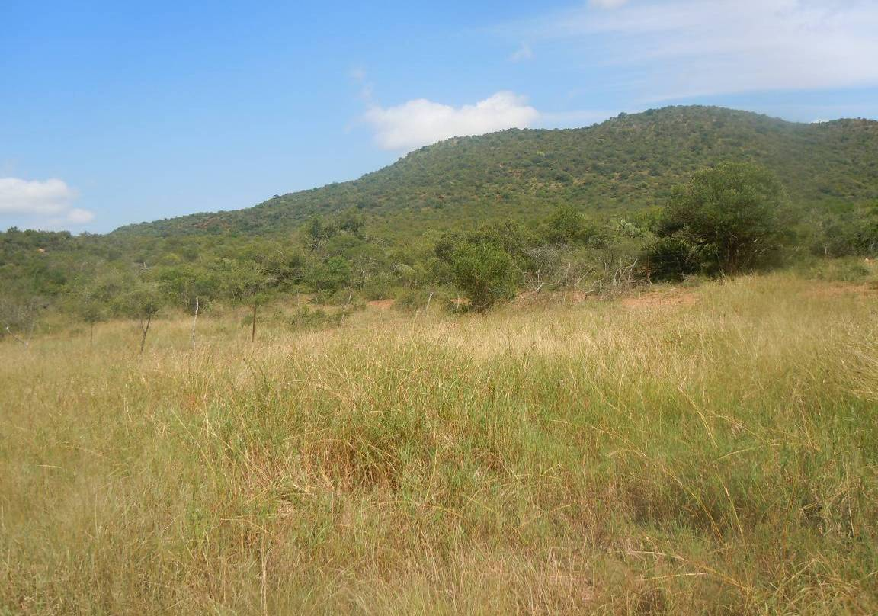
Figure 7: Cleared Open Plains Bushveld in the foreground, Open Plains Bushveld in the middle and Mountain Slope Bushveld in the background

4. Lydenburg Thornveld
The Option 1 route crosses a small section of the Lydenburg Thornveld on the undulating mountain plateau area above the Strydom tunnel. This area is a wooded grassland, quite cold with frost during winter. Species such as the frost hardy Acacia karroo, Acacia caffra, Cussonia paniculata Diospyros lycioides and Euclea crispa are prominent.

The following plant species were recorded from this plant community:

Trees and Shrubs

Acacia caffra d
Acacia karroo dM
Acacia robusta
Cussonia paniculata
Diospyros lycioides
Euclea crispa M
Dombeya rotundifolia
Rubus transvaalensis
Ehretia rigida M
Gymnosporia buxifolia M
Mundulea sericea M
Rhoicissus tridentata M
Searsia leptodictya
Searsia pyroides
Ziziphus mucronata M

Grasses

Aristida congesta
Aristida congesta subsp barbicollis
Aristida diffusa
Bewsia biflora
Brachiaria serrata
Cymbopogon excavatus
Digitaria eriantha
Diheteropogon amplectens
Eragrostis superba
Heteropogon contortus d
Melinis repens
Microchloa caffra
Monocymbium ceresiiforme
Panicum maximum
Panicum natalense
Pogonarthria squarrosa
Schizachyrium sanguineum
Setaria sphacelata
Themeda triandra d
Tristachya leucothrix

Forbs

Anthospermum rigidum
Commelina africana M
Dicoma anomala
Elephantorrhiza elephantina M
Euphorbia clavarioides
Evolvulus alsinoides M
Helichrysum cephaloideum
Helichrysum rugulosum
Hibiscus trionum
Kohautia amatymbica
Lippia javanica
Pentarrhinum insipidum M
Schistostephium crataegifolium
Senecio coronatus
Senecio microglossus
Senecio tamoides M
Solanum incanum M
Solanum panduriforme M
Tephrosia sp
Vernonia oligocephala

Lydenburg Thornveld
Status | Open wooded grassland
Soil | sandy-loam | Rockiness  % | 1
Conservation priority: | Medium | Sensitivity: | Medium
Agricultural potential: | Medium | Need for rehabilitation | Low
Dominant spp. | Acacia karroo, Acacia caffra, Euclea crispa

Species of Conservation Concern
A Threatened species and Species of Conservation Concern list for the Grid 2430CB was obtained from the POSA database on the SANBI website. Threatened species are those that are facing high risk of extinction, indicated by the categories Critically Endangered, Endangered and Vulnerable. Species of Conservation Concern include the Threatened Species, but additionally have the categories Near Threatened, Data Deficient, Critically Rare, Rare and Declining. This is in accordance with the new Red List for South African Plants (Raimondo et al. 2009).

The following species of conservation concern were previously recorded from the Grid 2430DA (SANBI, POSA website April 2011):

Species | Status
Adenia fruticosa Burtt Davy subsp. fruticosa | NT
Aloe fouriei D.S.Hardy & Glen | DDT
Ansellia africana Lindl. | Declining
Ceropegia distincta N.E.Br. subsp. verruculosa R.A.Dyer | DDD
Combretum petrophilum Retief | Rare
Dicliptera fruticosa K.Balkwill | NT
Dracaena transvaalensis Baker | Rare
Eulophia speciosa (R.Br. ex Lindl.) Bolus | Declining
Euphorbia sekukuniensis R.A.Dyer | Rare
Gladiolus macneilii Oberm. | CR
Gladiolus pavonia Goldblatt & J.C.Manning | CR
Indigofera leendertziae N.E.Br. | DDT
Jamesbrittenia macrantha (Codd) Hilliard | NT
Khadia alticola Chess. & H.E.K.Hartmann | Rare
Lydenburgia cassinoides N.Robson | NT
Ocimum tubiforme (R.D.Good) A.J.Paton | CR
Orbea gerstneri (Letty) Bruyns subsp. gerstneri | Rare
Pentatrichia alata S.Moore | DDD
Rhoicissus laetans Retief | Rare
Searsia batophylla (Codd) Moffett | VU
Thesium davidsonae Brenan | VU

None of these species occur in this plant community as the habitat is not suitable for any of them.

Conclusion
This plant community is fairly high in species richness with no red data species or protected species found in the survey. It is also a very small area that will be crossed by the line. The construction of the line can be supported.

5. Poung Dolomite Mountain Bushveld
This is a narrow band of bushveld on dolomite, in the vicinity of the Strydom tunnel. It is situated along the western drier part of the Escarpment. The vegetation is woodland with a dense shrub layer. It occurs on the low and high mountain slopes in the area. The geology is dolomite and the shallow, rocky soils are of the Mispah soil Form. A very small, almost negligible part of this vegetation is crossed by Options 1, 3 and 4.
Poung Dolomite Mountain Bushveld
Status | Open to dense bushveld
Soil | sandy-loam | Rockiness  % | 1
Conservation priority: | Medium-High | Sensitivity: | Medium-High
Agricultural potential: | Low | Need for rehabilitation | Low
Dominant spp. | Acacia nigrescens, Acacia nilotica, Combretum apiculatum

The vegetation is dominated by the woody layer with several woody species present.

Trees and Shrubs

Acacia ataxacantha,
Acacia gerrardii
Acacia nigrescens d
Acacia nilotica d
Acacia tortilis
Aloe cryptopoda p
Boscia albitrunca M
Brachylaena ilicifolia
Carissa bispinosa
Celtis africana
Combretum apiculatum d
Combretum hereroense
Combretum molle
Croton gratissimus
Cussonia spicata
Dichrostachys cinerea
Dombeya rotundifolia
Euclea crispa M
Euclea undulata M
Euphorbia tirucalli M
Grewia bicolor
Grewia flava
Gymnosporia senegalensis M
Hippobromus pauciflorus
Kirkia wilmsii
Ozoroa albicans
Pouzolzia mixta
Rhoicissus tridentata
Searsia leptodictya
Senna petersiana
Tecoma capensis
Vitex obovata subsp wilmsii

Grasses

Aristida canescens
Aristida congesta
Aristida transvaalensis
Bewsia biflora
Bothriochloa insculpta
Brachiaria serrata
Digitaria eriantha
Diheteropogon amplectens
Elionurus muticus
Enneapogon scoparius
Eragrostis lehmanniana
Eragrostis superba
Heteropogon contortus
Loudetia simplex
Melinis nerviglume
Melinis repens s. repens
Panicum deustum
Panicum maximum
Themeda triandra

Forbs

Abutilon angulatum
Asparagus intricatus
Asparagus suaveolens
Barleria saxatilis
Blepharis integrifolia
Cheilanthes dolomitica
Clerodendrum ternatum
Commelina africana M
Corchorus asplenifolius
Euphorbia schinzii
Evolvulus alsinoides
Geigeria burkei
Hibiscus aethiopicus
Hypoestes forskaolii
Kohautia cynanchica
Kyphocarpa angustifolia
Ocimum americanum
Phyllanthus glaucophyllus
Polygala hottentotta
Rhynchosia nitens
Sansevieria hyacinthoides
Stylochiton natalensis
Tephrosia purpurea
Tetradenia brevispicata,
Tragia dioica
Waltheria indica W
Xerophyta retinervis

Species of Conservation Concern
Although Matthews (1991), Van Wyk & Smith (2001) and Mucina & Rutherford (2006) mention that several endemic plant species occur on this dolomite area, the area crossed by the lines is so small that none of these species were recorded.

Conclusion

As far as vegetation is concerned, the development of the power lines can be supported in this area.
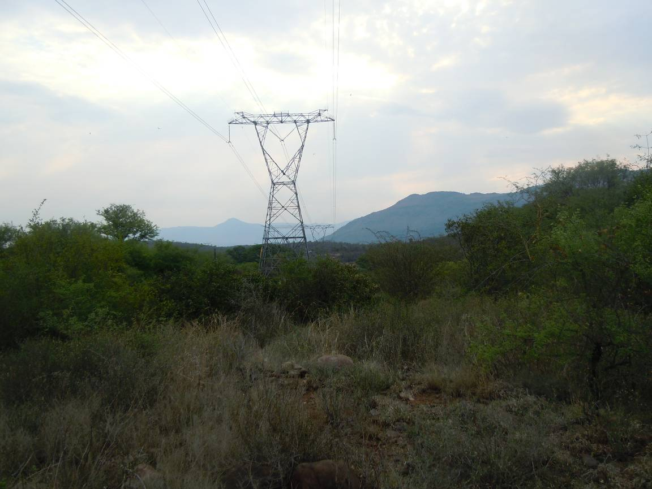
Figure 8: Poung Dolomite Mountain Bushveld

6. Northern Escarpment Quartzite Sourveld
A very small part of this veld type is close to the proposed route of Route 1, though it is so small that this vegetation is not discussed further.

7. Northern Mistbelt Forest
The proposed lines cannot go through indigenous forest. The proposed Route 4 seems to cross a patch of forest, but this will not be allowed by the authorities. This is one of the reasons why Route 4 was eliminated as an option. This vegetation is not discussed further.

8. Tzaneen Sour Bushveld
This vegetation stretches in a narrow band on the plains and all along the lower footslopes and hills of the escarpment. The vegetation is tall open bushveld with a tall grass layer. The geological substrate is gneiss and granite and the soils are shallow sandy and rocky lithosols. This is very dense, often tall bushveld, merging into forest-like vegetation. Only the route of Option 4 transects this vegetation, albeit a very narrow band. This vegetation contains many large trees and also has a very high species richness. Large Ficus trees (various species) together with several other large trees are prominent. Several threatened species occur in this vegetation.

The following species are present:
Trees and shrubs

Acacia davyi
Acacia polyacantha
Acacia sieberiana
Albizia versicolor
Antidesma venosum
Bauhinia galpinii
Catha edulis M
Faurea rochetiana
Faurea saligna
Ficus burkei
Ficus petersii
Ficus sansibarica
Heteropyxis natalensis
Parinari curatellifolia
Peltophorum africanum
Piliostigma thonningii
Pterocarpus angolensis P
Pterocarpus rotundifolius
Sclerocarya birrea P
Searsia pentheri
Terminalia sericea
Trichilia emetica

Grasses

Alloteropsis semialata
Andropogon schirensis
Aristida congesta
Bothriochloa bladhii
Cymbopogon caesius
Cynodon dactylon
Diheteropogon amplectens
Heteropogon contortus
Hyparrhenia cymbaria
Hyperthelia dissoluta
Setaria nigrirostris
Setaria sphacelata
Themeda triandra

Forbs
Some forb species occur scattered in the grassy layer, and these are not abundant:

Agathisanthemum bojeri
Barleria elegans
Dicliptera clinopodia
Polygala producta

Species of Conservation Concern

Species | Status
Aloe hardyi H.F.Glen | Rare
Combretum petrophilum Retief | Rare
Dracaena transvaalensis Baker | Rare
Encephalartos brevifoliolatus Vorster | EW
Encephalartos cupidus R.A.Dyer | CR
Encephalartos paucidentatus Stapf & Burtt Davy | VU
Gladiolus macneilii Oberm. | CR
Helichrysum junodii Moeser | Rare
Thesium davidsonae Brenan | VU

Several species of conservation concern are present in this dense vegetation. Although none of these were recorded during the field survey, possibly due to the very narrow band of this vegetation, but also due to the inaccessibility, it is certain that some of them will occur on the route. This is one of the reasons why Route 4 is eliminated as an option.

Conclusion
Due to the dense vegetation, species richness and possible presence of threatened species, it is suggested to avoid this route.

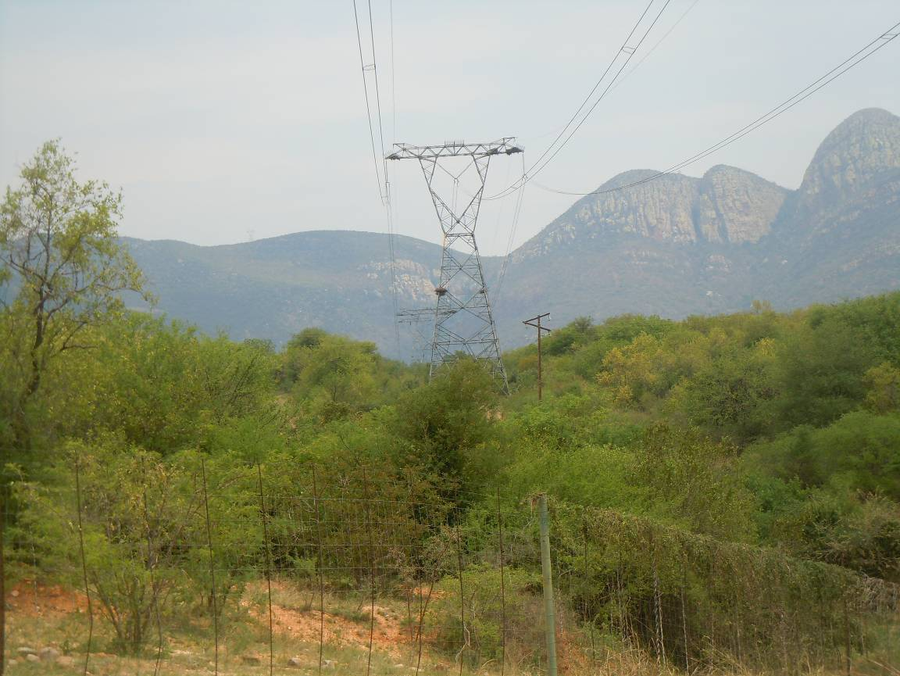
Figure 9: Dense Tzaneen Sour Bushveld

9. Granite Bushveld
The granite bushveld on the granite Lowveld plains cover the largest part of all the transects in the study site. This large granite plain is covered with the “typical” Lowveld bushveld, well know, for example, from large parts of the Kruger National Park.

Prominent species are Combretum apiculatum on the sandy or gravelly upland sites, while Acacia nigrescens and other Acacia species are prominent on the more clayey bottomland sites. Many species could be recorded, as this area is often close to roads and accessible.

The following plant species were recorded in this plant community:

Trees and shrubs

Acacia exuvialis
Acacia gerrardii
Acacia nigrescens d
Acacia nilotica
Acacia sieberiana M
Acacia tortilis d
Agave sisalana A
Albizia harveyi d
Bolusanthus speciosa
Capparis tomentosa
Cassia abbreviata
Combretum apiculatum D
Combretum collinum
Combretum hereroense
Combretum imberbe P
Combretum zeyheri M
Commiphora africana
Cordia ovalis
Dalbergia melanoxylon
Dichrostachys cinerea dM
Dodonaea angustifolia M
Dombeya rotundifolia M
Ehretia amoena
Ehretia rigida m
Erythrina lysistemon
Euclea divinorum M
Euclea natalensis
Ficus stuhlmanni
Flueggea virosa
Gardenia volkensii
Grewia bicolor
Grewia flava
Grewia flavescens
Grewia monticola
Gymnosporia senegalensis M
Lannea discolor
Lannea schweinfurthii
Lantana camara A
Ozoroa engleri
Pappea capensis
Pavetta schumanniana
Pavetta schumanniana M
Peltophorum africanum M
Philenoptera violacea PM
Pterocarpus angolensis PM
Pterocarpus rotundifolius
Schotia brachypetala
Schotia capitata
Sclerocarya birrea PM
Searsia guenzii
Searsia leptodictya
Senna didymobotrya A
Senna petersiana DM
Spirostachys africana p
Terminalia prunoides
Terminalia sericea DM
Xeromphis obovata
Ziziphus mucronata M

Grasses
Aristida adscensionis
Aristida congesta
Aristida diffusa
Bothriochloa insculpta
Brachiaria nigropedata
Cenchrus ciliaris
Digitaria eriantha
Enneapogon cenchroides
Enneapogon scoparius
Eragrostis rigidior
Heteropogon contortus
Hyperthelia dissoluta
Melinis repens
Panicum maximum
Perotis patens
Pogonarthria squarrosa
Sporobolus africanus
Sporobolus ioclados
Tricholaena monachne
Trichoneura grandiglumis
Urochloa mosambicensis d

Forbs

Achyranthes aspera
Acrotome inflata
Agathisanthemum bojeri
Aspilia mossambicensis
Becium filamentosum
Bidens pilosa W
Bulbostylis hispidula
Chamaecrista absus
Commelina benghalensis
Commelina erecta
Cyperus esculentus W
Dicerocaryum zanguebarium M
Evolvulus alsinoides M
Geigeria burkei
Gomphrena celosioides W
Helichrysum sp
Heliotropium steudneri
Heliotropium strigosum
Hermannia sp
Hermannia tomentosa
Hermbstaedtia odorata
Hibiscus cannabinus
Hibiscus sp
Indigofera filipes
Kohautia virgata
Kyphocarpa angustifolia
Leucas glabrata
Ocimum americanum
Phyllanthus maderaspatensis
Rhynchosia totta
Richardia braziliensis W
Schkruhria pinnata WM
Solanum panduriforme W
Tagetes minuta W
Tephrosia grandiflora
Waltheria indica W
Zornia milneana

Species of Conservation Concern

Asphodelaceae | Aloe hardyi H.F.Glen | Rare
Asphodelaceae | Aloe thompsoniae Groenew. | Rare
Apocynaceae | Brachystelma parvulum R.A.Dyer | VU
Combretaceae | Combretum petrophilum Retief | Rare
Celastraceae | Elaeodendron transvaalense (Burtt Davy) R.H.Archer | NT
Zamiaceae | Encephalartos dyerianus Lavranos & D.L.Goode | CR
Zamiaceae | Encephalartos lebomboensis I.Verd. | EN
Proteaceae | Protea laetans L.E.Davidson | VU
Rosaceae | Prunus africana (Hook.f.) Kalkman | VU
Anacardiaceae | Searsia batophylla (Codd) Moffett | VU

None of these species were recorded during the field survey. The flat granite plains are not suitable habitat for these species, which are all nich specialists, or occur on the mountain areas to the west of the granite plains.

Conclusion
Several game farms and cattle farms are found in this area.
Special care will be needed in the crossing of the spruit systems within this area.
The construction of the line can be supported.

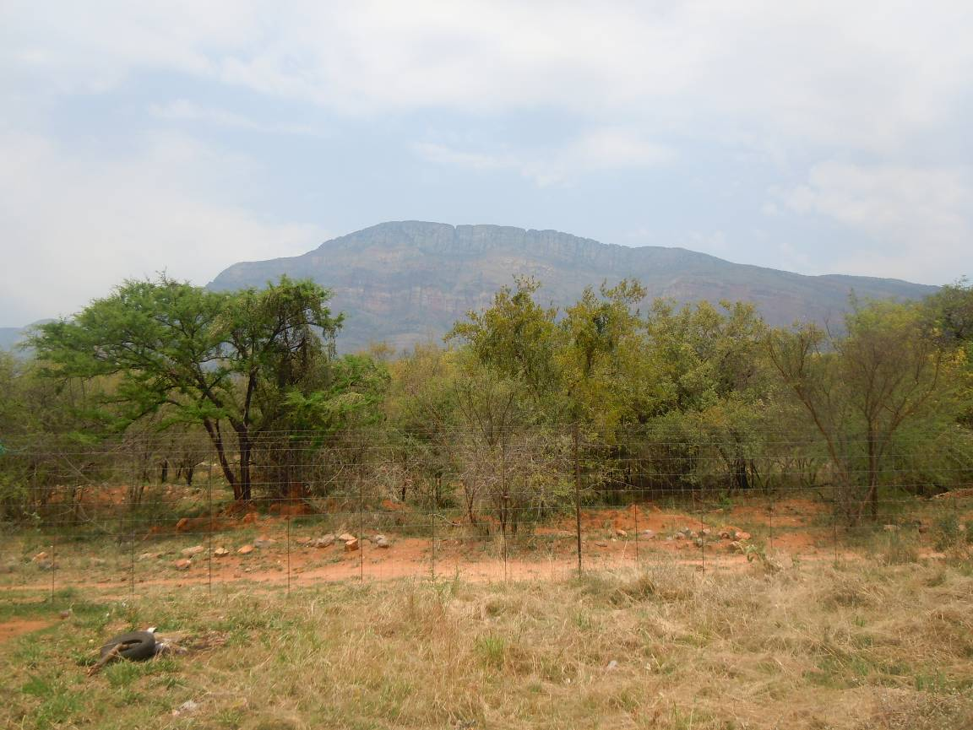
Figure 10:Typical Granite Lowveld vegetation

10. Lowveld Rugged Mopaneveld
Only Routes 1 and 2 will transect this vegetation type in the north-eastern extreme of the study area. The Foskor substation is located on the northern boundary of this vegetation type. This is the rugged hilly area of the Olifants River valley, south of Phalaborwa. The landscape is irregular plains and rocky hills, with moderate to steep slopes. Colophospermum mopane is often restricted to valleys, while the hills are dominated by Acacia nigrescens with Combretum apiculatum also present.

The following plant species were recorded in this plant community:

Trees and shrubs

Acacia exuvialis
Acacia nigrescens
Acacia nilotica
Berchemia discolor
Boscia albitrunca P
Colophospermum mopane D
Combretum apiculatum
Combretum hereroense
Combretum imberbe P
Combretum zeyheri M
Commiphora africana
Commiphora mollis
Dalbergia melanoxylon
Dichrostachys cinerea M
Dodonaea angustifolia M
Dombeya rotundifolia M
Ehretia amoena
Ehretia rigida M
Erythrina lysistemon
Euclea natalensis
Ficus abutilifolia
Flueggea virosa
Gardenia volkensii
Grewia bicolor
Grewia flavescens
Grewia hexamita
Grewia monticola
Grewia villosa
Gymnosporia senegalensis M
Hexalobus monopetalus
Kirkia wilmsii
Lannea discolor
Manilkara mochisia
Ozoroa engleri
Pappea capensis
Pavetta schumanniana M
Peltophorum africanum M
Philenoptera violacea PM
Pterocarpus rotundifolius
Rhigozum zambesiacum
Sclerocarya birrea PM
Terminalia prunoides
Terminalia sericea DM

Grasses
Aristida adscensionis
Aristida congesta
Bothriochloa radicans
Cenchrus ciliaris
Digitaria eriantha
Enneapogon cenchroides
Enneapogon scoparius
Eragrostis rigidior
Fingerhuthia africana
Heteropogon contortus
Melinis repens
Panicum maximum
Pogonarthria squarrosa
Sporobolus panicoides
Tricholaena monachne
Trichoneura grandiglumis
Urochloa mosambicensis d

Forbs

Achyranthes aspera
Agathisanthemum bojeri
Aspilia mossambicensis
Chamaecrista mimosoides
Commelina benghalensis
Commelina erecta
Crabbea velutina
Evolvulus alsinoides
Geigeria burkei
Gomphrena celosioides
Gossypium africanum
Heliotropium steudneri
Heliotropium strigosum
Hemizygia elliottii
Hermannia tomentosa
Hermbstaedtia odorata
Hibiscus sidiformis
Kohautia virgata
Kyphocarpa angustifolia
Leucas glabrata
Melhania forbesii
Melhania rehmannii
Ocimum americanum
Phyllanthus asperulatus
Solanum panduriforme
Waltheria indica
Xerophyta retinervis
Zornia milneana

Species of Conservation Concern
Species | Status
Ansellia africana Lindl. | Declining

This epiphytic orchid is often found growing on threes within this plant community.

Conclusion
Game farming is a special feature in this area.
Special care will be needed in the crossing of spruit systems.
The construction of the line can be supported.

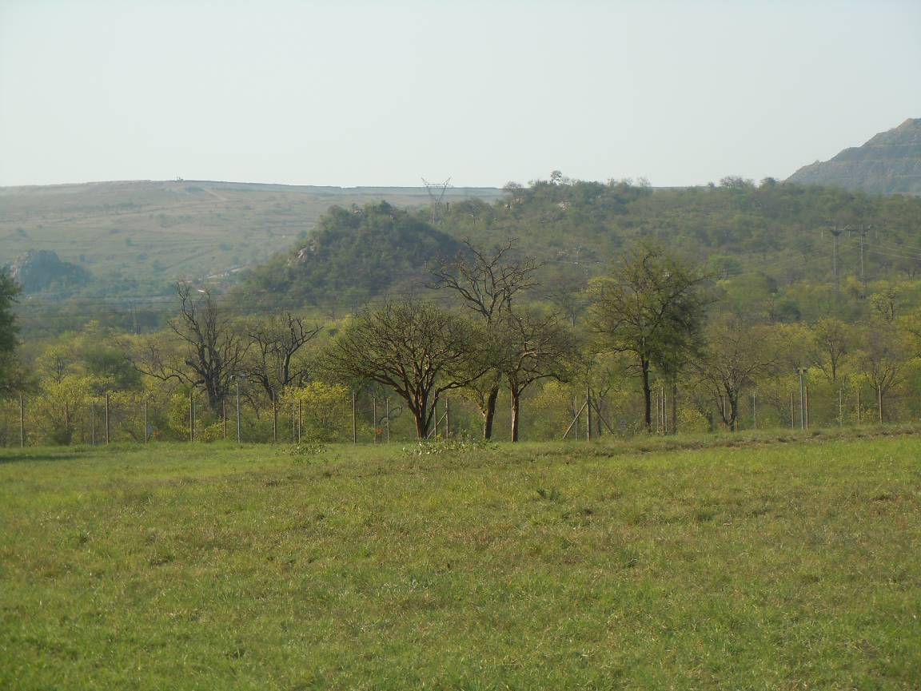
Figure 11: Lowveld Rugged Mopaneveld in the background

11. Phalaborwa-Timbavati Mopaneveld
Only Routes 1 (small part) and 4 will transect this vegetation type in the north-eastern extreme of the study area. The Foskor substation is located on the southern boundary of this vegetation type. This is the flat plains west of Phalaborwa. The landscape is an undulating plain with Colophospermum mopane and Acacia nigrescens in the lower lying areas, while Combretum apiculatum and Terminalia sericea becomes more prominent on upland sites.

The following plant species were recorded in this plant community:

Trees and shrubs

Acacia exuvialis
Acacia nigrescens
Acacia tortilis
Albizia harveyi
Boscia albitrunca P
Cassia abbreviata
Cissus cornifolia
Colophospermum mopane D
Combretum apiculatum d
Combretum hereroense
Combretum imberbe P
Combretum zeyheri M
Commiphora africana
Commiphora mollis
Dalbergia melanoxylon
Dichrostachys cinerea M
Ehretia amoena
Ehretia rigida
Euclea divinorum
Flueggea virosa
Gardenia volkensii
Grewia bicolor
Grewia flavescens
Grewia hexamita
Grewia monticola
Grewia villosa
Gymnosporia senegalensis M
Lannea discolor
Maerua parvifolia
Ozoroa engleri
Pappea capensis
Pavetta schumanniana M
Peltophorum africanum M
Philenoptera violacea PM
Sclerocarya birrea PM
Strychnos madagascariensis
Terminalia prunoides
Terminalia sericea dM

Grasses
Aristida adscensionis
Aristida congesta
Bothriochloa radicans
Brachiaria nigropedata
Cenchrus ciliaris
Digitaria eriantha
Andropogon gayanus
Fingerhuthia africana
Enneapogon scoparius
Eragrostis rigidior
Heteropogon contortus
Melinis repens
Panicum maximum
Perotis patens
Pogonarthria squarrosa
Schmidtia pappophoroides
Themeda triandra
Tricholaena monachne
Trichoneura grandiglumis
Urochloa mosambicensis d

Forbs

Achyranthes aspera
Acrotome inflata
Agathisanthemum bojeri
Aspilia mossambicensis
Chamaecrista mimosoides
Clerodendrum ternatum
Commelina benghalensis
Commelina erecta
Evolvulus alsinoides
Gomphrena celosioides
Heliotropium steudneri
Heliotropium strigosum
Hemizygia elliottii
Hermannia glanduligera
Hermannia tomentosa
Hermbstaedtia odorata
Ipomoea magnusiana
Kohautia virgata
Kyphocarpa angustifolia
Leucas glabrata
Melhania forbesii
Ocimum americanum
Solanum panduriforme
Tephrosia polystachya
Waltheria indica
Zornia milneana

Species of Conservation Concern

Species | Status
Aloe thompsoniae Groenew. | Rare
Encephalartos dyerianus Lavranos & D.L.Goode | CR
Encephalartos lebomboensis I.Verd. | EN

None of these species were found during the field survey.

Conclusion
Game farming is a special feature in this area.
Special care will be needed in the crossing of spruit systems.
The construction of the line can be supported.

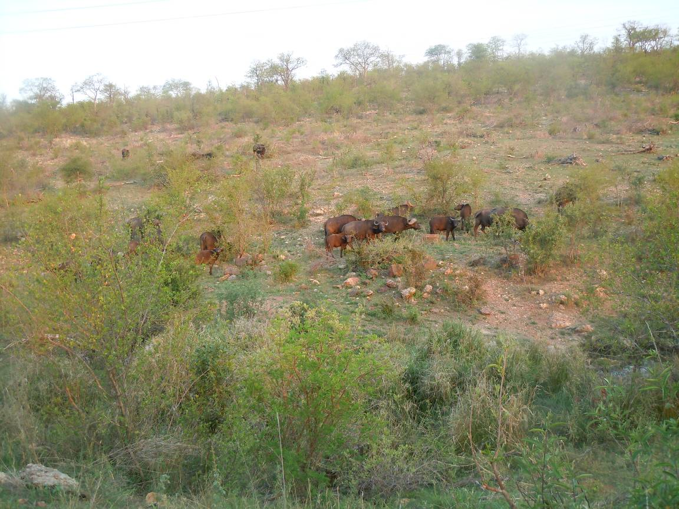
Figure 12: Game farming in the Lowveld areas.

12 River and Spruit Systems
Several River or spruit crossings occur along the transect routes. At the smaller spruits no riparian zone is present, the vegetation is continuous with the adjacent bushveld vegetation. However, the larger rivers have a distinct riparian zone, with large trees for example Faidherbia albida, Acacia galpinii, Acacia robusta and Philenoptera violacea.

The following species were recorded at a larger river:
Woody species

Acacia galpinii
Acacia robusta
Acacia tortilis
Combretum apiculatum
Combretum imberbe P
Combretum microphyllum
Dichrostachys cinerea
Diospyros mespiliformis
Faidherbia albida D
Ficus sycomorus
Grewia bicolor
Grewia monticola
Peltophorum africanum
Philenoptera violacea P
Phoenix reclinata
Sclerocarya birrea MP
Terminalia sericea
Ziziphus mucronata M

Grasses

Aristida congesta
Cynodon dactylon
Dactyloctenium aegyptium
Digitaria eriantha
Eragrostis heteromera
Eragrostis rigidior d
Eragrostis superba
Heteropogon contortus D
Melinis repens
Pogonarthria squarrosa d
Tricholaena monachne
Trichoneura grandiglumis

Forbs

Agathisanthemum bojeri
Ageratum conyzoides W
Cyperus sexangularis
Lippia rehmannii
Schkruhria pinnata W
Melanthera scandens
Solanum incanum W
Solanum panduriforme W
Xanthium strumarium W

River and Spruit crossings
Status | River and spruit linear wetlands
Soil | Sandy or clayey | Rockiness | 0%
Conservation priority: | High | Sensitivity: | High
Agricultural potential: | Low | Need for rehabilitation | Low
Dominant spp. | Combretum imberbe, Faidherbia albida, Acacia galpinii, Diospyros mespiliformis, Ficus sycomorus, Acacia robusta, Philenoptera violacea, Phoenix reclinata

Conclusion
No river or spruit is very wide, so the lines can easily cross these river or spruit systems. Care should however be taken to place pylons adequately away from river or spruit banks, avoiding any damage to the banks or water courses. Erosion should be avoided at all times.

8 DISCUSSION
The vegetation of all four alternatives was investigated. From the desktop study, confirmed by the field survey, option 3, which runs from Burgersfort to Ohrigstad along the R555, was eliminated. This is because the route along the R555 runs for most of the way in a narrow valley, with the Mabitsana River and the tarred R555 in this valley. The line will have to run for most of the way on the sensitive mountain foot slopes and cross the river and road several times. Furthermore, many irrigated agricultural enterprises occur in the Ohrigstad area, stretching all the way to Marapeng. This mosaic of narrow river valley, river, mountain slopes and agriculture where-ever the valley is a bit broader, causes the route to be unsuitable. From an ecological perspective both the riverine vegetation and the vegetation of the mountain slopes have a high ecological sensitivity. Therefore this entire valley forms an ecologically sensitive ecosystem. This is also a much longer route.

Furthermore, from the desktop study, confirmed by the field survey, option 4, was eliminated. The line of this option runs through nine vegetation types, and over very high and steep mountains of Sekhukhune Mountain Bushveld and Ohrigstad Mountain Bushveld with two endangered ecosystems (Sekhukhune Mountainlands and Sekhukhune Norite Bushveld, SANBI & DEAT 2009), Poung Dolomite Mountain Bushveld with endangered Malmani Karstland (SANBI & DEAT 2009), the vulnerable Northern Escarpment Quartzite Sourveld (Mucina & Rutherford (2006), Northern Mistbelt Forest area and the vulnerable Tzaneen Sour Bushveld (SANBI & DEAT 2009). Especially the Great Escarpment area consists of very rugged and high mountains, resulting in a very difficult route with several threatened ecosystems.

Alternative Routes 1 and 2 were further investigated in more detail by field surveys. The vegetation along these routes is described in detail, including the protected and red data species. Medicinal plants and aliens and weeds are indicated.

The most difficult part of the route is from the Merensky substation through Orichstad Mountain Bushveld which is an extremely mountainous area with sensitive vegetation. This part of the line transects quite sensitive vegetation and it is suggested that a walkthrough in this area is essential.

The most serious limitation on the Lowveld plains where the line transects the Granite Lowveld vegetation type, is the abundance of the protected tree Sclerocarya birrea. It is certain that several of these trees will be in the way of the transect.
Locally are also the river and spruit crossings. No river or spruit is very wide, so the lines can easily cross these rivers or spruits systems. Care should be taken to place pylons adequately away from river or spruit banks, avoiding any damage to the banks or water courses. Erosion should be avoided at all times.

Another factor in this area is that large properties are game farms and lodges. These areas are effectively conserved by the owners, and it is realised that the public participation is an important issue. After finalisation of the exact transect, a walkthrough will have to confirm any issues regarding vegetation.

From an ecological perspective, Alternative 1 is the preferred route.

11. REFERENCES

Acocks, J.P.H. 1988. Veld types of South Africa, 3rd ed. Memoirs of the Botanical Survey of South Africa. 57: 1–146.

Bredenkamp, G.J. 1982. ‘n Plantekologiese studie van die Manyeleti Wildtuin. DSc thesis, University of Pretoria, Pretoria.

Bredenkamp, G.J. & Brown, L.R. 2001. Vegetation – A reliable ecological basis for environmental planning. Urban Greenfile Nov-Dec 2001: 38-39.

Department of Environmental Affairs and Tourism. 2007. National Environmental Management: Biodiversity Act, 2004 (Act 10 of 2004): Publication of Lists of Critically Endangered, Endangered, Vulnerable and Protected Species. Government Notices.

Gertenbach, W.P.D. 1983a. Ekologiese studie van die suidelikste Mopaneveld in the Kruger Nasionale Wildtuin. DSc thesis, University of Pretoria, Pretoria.

Gertenbach, W.P.D. 1983b. Landscapes in the Kruger National park, Koedoe 26: 9-121

Henderson, L. 2001. Alien weeds and invasive plants. ATC, Pretoria.

Low, A.B. & Rebelo, A.G. (eds) 1996 Vegetation of South Africa, Lesotho and Swaziland. Dept Environmental Affairs & Tourism, Pretoria.

Matthews, W.S. 1991. Phytosociology of North-eastern Mountain Sourveld. MSc thesis, University of pretoria, Pretoria.

Mucina, L, & Rutherford, M.C. (Eds.) 2006. The vegetation of South Africa, Lesotho and Swaziland. Strelitzia 19. South African National Biodiversity Institute, Pretoria.
Mucina, L., Bredenkamp, G.J., Hoare, D.B. & Mcdonald, D.J. 2000. A National vegetation database for South Africa. South Africa Journal of Science 96:497-498.

Mueller-Dombois, D. & Ellenberg, H. 1974. Aims and methods of vegetation ecology. Wiley, New York.

Raimondo, D., Von Staden, L., Foden, W., Victor, J.E., Helme, N.A., Turner, R.C. Kamundi, D.A. & Manyama, P.A. (Eds.). 2009. Red list of South African plants 2009. Strelitzia 25:1-668.

Siebert, S.J. 1998. .Ultramafic substrates and floristic patterns in Sekhukhuneland, South Africa. MSc thesis, University of Pretoria, Pretoria

Siebert, S.J. 2001 Vegetation on the ultramafic soils of the Sekhukhuneland Centre of Endemism. PhD thesis, University of Pretoria, Pretoria
.
Siebert, S.J., Van Wyk, A.E. & Bredenkamp, G.J. 2001. Endemism in the flora of ultramafic areas of Sekhukhuneland, South Africa South African Journal of Science 97:529-532.

Siebert, S.J., Victor, J., Van Wyk, A.E. & Bredenkamp, G.J. 2002a. An assessment of threatened plants and conservation in Sekhukhuneland. PlantLife 26:7-18.

Siebert, S.J. Van Wyk, A.E. & Bredenkamp, G.J. 2002b. The physical environment and major vegetation types of Sekhukhuneland, South Africa. South African Journal of Botany 68: 127-142.

Siebert S.J., Van Wyk A.E., Bredenkamp G.J. & Du Plessis F. 2002c. Grasslands and wetlands of the Sekhukhuneland Centre of Plant Endemism. Bothalia 32(2): 211–231.

Siebert S.J., Van Wyk A.E., & Bredenkamp G.J. 2002d. Vegetation ecology of Sekhukhuneland, South Africa: Combretum hereroense – Grewia vernicosa Open Mountain Bushveld. South African Journal of Botany 68(4): 497-517.

Siebert S.J., Van Wyk A.E., & Bredenkamp G.J. 2002e. Vegetation ecology of Sekhukhuneland, South Africa: Kirkia wilmsii – Terminalia prunioides Closed Mountain Bushveld. South African Journal of Botany 68(4): 474-496.

Siebert, S.J., Van Wyk, A.E., Bredenkamp, G.J. & Siebert, F. 2003. Vegetation of the rock habitats of the Sekhukhuneland Centre of Plant Endemism, South Africa. Bothalia 33(2): 207-228.

The Conservation of Agricultural Resources Act, 1983 (Act No. 43 of 1983)

The Environmental Conservation Act, 1989 (Act No. 73 of 1989)

The National Environment Management Act, 1998 (Act No. 107 of 1998)

The National Environmental Management Biodiversity Act, 2004. (Act 10 0f 2004). Government Gazette RSA Vol. 467, 26436, Cape Town, June 2004.

The National Environmental Management: Biodiversity Act, 2004. (Act 10 0f 2004), Draft list of threatened ecosystems. Government Gazette RSA Vol. 1477, November 2009.

The National Forests Act, 1998 (Act 84 of 1998)

Van Wyk, A.E. & Smith, G.F. 2001. Regions of floristic endemism in southern Africa. Umdaus Press, Hatfield, Pretoria.

Van Wyk, B.E., Van Oudtshoorn, B. & Gericke, N. 1997. Medicinal plants of South Africa. Briza, Pretoria.

Westhoff, V. & Van der Maarel, E. 1978. The Braun-Blanquet approach. In: Whittaker, R.H. (ed.) Classification of plant communities. W. Junk, The Hague.

ABRIDGED CURRICULUM VITAE: GEORGE JOHANNES BREDENKAMP

Born: 10 February 1946 in Johannesburg, South Africa.
Citizenship: South African
Marital status: Married, 1 son, 2 daughters

Present work address
Department of Botany, University of Pretoria, Pretoria, 0002, South Africa
Tel:(27)(12)420-3121 Fax: (27)(12)362 5099
E-Mail: gbredenk@postino.up.ac.za
or
EcoAgent CC
PO Box 25533, Monument Park, 0105, South Africa
Tel: (27)(12) 346 3180
Fax: (27)(12) 460 2525
Cell 082 5767046
E-Mail: ecoagent@mweb.co.za

Qualifications:
1963 Matriculation Certificate, Kemptonpark High School
1967 B.Sc. University of Pretoria, Botany and Zoology as majors,
1968 B.Sc. Hons. (cum laude) University of Pretoria, Botany.
1969 T.H.E.D. (cum laude) Pretoria Teachers Training College.
1975 M.Sc. University of Pretoria, Plant Ecology .
1982 D.Sc. (Ph.D.) University of Pretoria, Plant Ecology.

Theses: (M.Sc. and D.Sc.) on plant community ecology and wildlife management in nature reserves in South African grassland and savanna.

Professional titles:
• MSAIE South African Institute of Ecologists and Environmental Scientists
- 1989-1990 Council member
• MGSSA Grassland Society of Southern Africa
- 1986 Elected as Sub-editor for the Journal
- 1986-1989 Serve on the Editorial Board of the Journal
- - 1990 Organising Committee: International Conference: Meeting Rangeland challenges in Southern Africa
- 1993 Elected as professional member
• PrSciNat. South African Council for Natural Scientific Professions Registration Number 400086/83
- 1993-1997 Chairman of the Professional Advisory Committee: Botanical Sciences
- 1993-1997: Council Member
- 1992-1994: Publicity Committee
- 1994-1997: Professional Registration Committee

Professional career:
- Teacher in Biology 1970-1973 in Transvaal Schools
- Lecturer and senior lecturer in Botany 1974-1983 at University of the North
- Associate professor in Plant Ecology 1984-1988 at Potchefstroom University for CHE
- Professor in Plant Ecology 1988-2008 at University of Pretoria.
- 2009 – current Professor Extra-ordinary in the Dept of Plant Science, University of Pretoria
- • Founder and owner of the Professional Ecological Consultancy firms Ecotrust Environmental Services CC and Eco-Agent CC, 1988-present.

Academic career:
• Students:
- Completed post graduate students: M.Sc. 53; Ph.D. 14.
- Presently enrolled post-graduate students: M.Sc. 4; Ph.D. 2.

• Author of:
- 175 scientific papers in refereed journals
- >150 papers at national and international congresses
- >250 scientific (unpublished) reports on environment and natural resources
- 17 popular scientific papers.
- 39 contributions in books

• Editorial Committee of
- South African Journal of Botany,
- Journal Grassland Society of Southern Africa,
- Bulletin of the South African Institute of Ecologists.
- Journal of Applied Vegetation Science.( Sweden)
- Phytocoenologia (Germany)

• FRD evaluation category: C2 (=leader in South Africa in the field of Vegetation Science/Plant Ecology)

Membership:
• International Association of Vegetation Science.
• British Ecological Society
• International Society for Ecology (Intecol)
• Association for the Taxonomic study of the Flora of Tropical Africa (AETFAT).
• South African Association of Botanists (SAAB)
1988-1993 Elected to the Council of SAAB.
1989-1990 Elected as Chairman of the Northern Transvaal Branch
1990 Elected to the Executive Council as Vice-President
1990- Sub-editor Editorial Board of the Journal
1991-1992 Elected as President (2-year period)
1993 Vice-President and Outgoing President
• Wildlife Management Society of Southern Africa
• Suid-Afrikaanse Akademie vir Wetenskap en Kuns
(=South African Academy for Science and Art).
• Wildlife Society of Southern Africa
1975 - 1988: Member
1975 - 1983: Committee member, Pietersburg Centre
1981 - 1982: Chairman, Pietersburg Centre
• Dendrological Society of Southern Africa
1984 - present: Member
1984 - 1988: Committee member, Western Transvaal Branch
1986 - 1988: Chairman, Western Transvaal Branch
1987 - 1989: Member, Central Committee (National level)
1990 - 2000: Examination Committee
• Succulent Society of South Africa
1987 - 2000
• Botanical Society of South Africa
2000 – present: Member
2001- 2008: Chairman, Pretoria Branch
2002 – 2006: Chairman, Northern Region Conservation Committee
2002- 2007: Member of Council

Special committees:
• Member of 10 special committees re ecology, botany, rangeland science in South Africa.
• Member of the International Code for Syntaxonomical Nomenclature 1993-present.

Merit awards and research grants:
1968 Post graduate merit bursary, CSIR, Pretoria.
1977-1979 Research Grant, Committee re Research Development, Dept. of Co-operation and Development, Pretoria.
1984-1989 Research Grant, Foundation for Research Development, CSIR, Pretoria.
1986-1987 Research Grant, Dept. of Agriculture and Water Supply, Potchefstroom.
1990-1997 Research Grant, Dept. of Environmental Affairs & Tourism, Pretoria.
1991-present Research Grant, National Research Foundation , Pretoria.
  - Research Grant, Water Research Commission.
1999-2003 Research Grant, Water Research Commission.
2006 South African Association of Botanists Silver Medal for outstanding contributions to South African Botany

Abroad:
1986 Travel Grant, Potchefstroom University for Christian Higher Education, Potchefstroom
Visits to Israel, Italy, Germany, United Kingdom, Portugal.
1987 Travel Grant, Potchefstroom University for Christian Higher Education, Potchefstroom.
Visits to Germany, Switzerland, Austria, The Netherlands, United Kingdom.
1990 Travel Grant, FRD.
Visit to Japan, Taiwan, Hong-Kong.
1991 Travel Grant, FRD.
Visits to Italy, Germany. Switzerland, Austria, France, The Netherlands, United Kingdom.
1993 Travel Grant, University of Pretoria.
Visits to the USA, Costa Rica, Czech Republic, Austria.
1994 Travel Grant FRD.
Visits to Switzerland, The Netherlands, Germany, Czech Republic.
1995 Travel Grant FRD, University of Pretoria
Visits to the USA
- Travel Grant, University of Pretoria
Visit to the UK.
- Travel Grant University of Pretoria, Visit Czech Republic, Bulgaria
- Travel Grant, University of Pretoria, Visit Czech Republic, Italy, Sweden
- Travel Grant, University of Pretoria, Visit Hungary, Spain, USA
- Travel Grant, University of Pretoria, Visit Poland, Italy, Greece.
- Travel Grant, NRF, Visit Brazil
2006 German Grant Invited lecture in Rinteln, Germany

Consultant
Founder and owner of Ecotrust Environmental Services CC and Eco-Agent CC
Since 1988 >250 reports as consultant on environmental matters, including:
- Game Farm and Nature Reserve planning,
- Environmental Impact Assessments,
- Environmental Management Programme Reports,
- Vegetation Surveys,
- Wildlife Management,
- Veld Condition and Grazing Capacity Assessments,
Red data analysis (plants and animals).

